

**AIL 202**

**DATABASE MANAGEMENT SYSTEMS LAB**

**LAB MANUAL STUDENT’S**

**Name of the Student : NAVANEETH SANTOSH**

**Roll No : ASI23CA047**

**Semester and Brach of Study : S4, CSE(AI)**

**ASIET VISION**

* To emerge as a Center of Excellence in Engineering, Technology and Management by imparting quality education, focusing on empowerment and innovation.

**ASIET MISSION**

* Impart quality professional education for total upliftment of the society.
* Create congenial academic ambience that kindles innovative thinking and research.
* Mould competent professionals who are socially committed and responsible citizens.

**VISION OF THE DEPARTEMENT**

* To be in the frontier of AI technology through quality of education, collaborative research and produce globally competitive, industry ready engineers with social commitment.

**MISSION OF THE DEPARTEMENT**

* Achieve excellence in the educational experience, fostering collaborative research through state-of-the-art infrastructure and innovative elements.
* Establish industry collaboration to address interdisciplinary challenges across diverse applications.
* Inspire students to develop into ethical, Innovative and entrepreneurial leaders through a socially-centered program.

**COURSE SYLLABUS**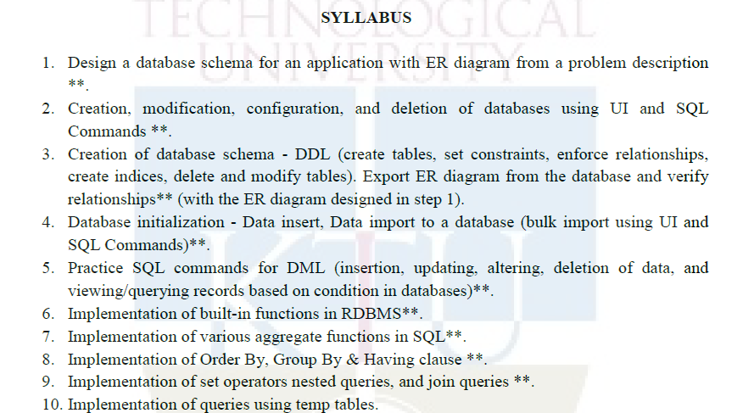

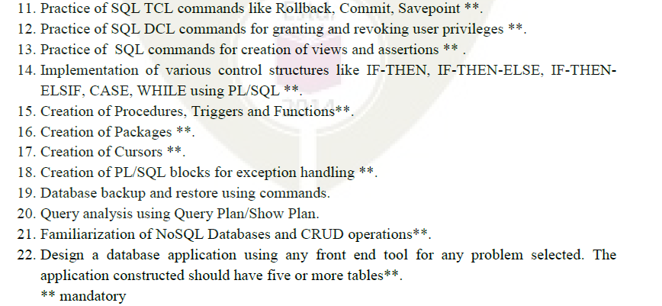

**Text Books**

1. Elmasri R. and S. Navathe, Database Systems: Models, Languages, Design and Application Programming, Pearson Education, 2013.

2. Sliberschatz A., H. F. Korth and S. Sudarshan, Database System Concepts, 6/e, McGraw Hill, 2011.

**References**

1. Adam Fowler, NoSQL for Dummies, John Wiley & Sons, 2015

2. NoSQL Data Models: Trends and Challenges (Computer Engineering: Databases and Big Data), Wiley, 2018

**COURSE OUTCOMES**

After the completion of this course, students shall be able to:

| **CO No.** | **Course Outcome** | **Knowledge Level** |
| --- | --- | --- |
| CO1 | Design database schema for a given real world problem-domain using standard design and modeling approaches. | Applying (K3) |
| CO2 | Construct queries using SQL for database creation, interaction, modification, and updation | Applying (K3) |
| CO3 | Design and implement triggers and cursors. | Applying (K3) |
| CO4 | Implement procedures, functions, and control structures using PL/SQL. | Applying (K3) |
| CO5 | Perform CRUD operations in NoSQL Databases. | Applying (K3) |
| CO6 | Develop database applications using front-end tools and back-end DBMS. | Create() |

**CO-PO and CO-PSO mapping :**

| **CO\PO&PSO** | **PO1** | **PO2** | **PO3** | **PO4** | **PO5** | **PO6** | **PO7** | **PO8** | **PO9** | **PO10** | **PO11** | **PO12** | **PSO1** | **PSO2** |
| --- | --- | --- | --- | --- | --- | --- | --- | --- | --- | --- | --- | --- | --- | --- |
| **1** | 2 | 2 | 2 |  | 2 |  |  | 2 |  | 2 |  | 2 |  |  |
| **2** | 3 | 2 | 3 |  | 1 |  |  | 2 |  | 2 |  | 2 |  |  |
| **3** | 3 | 2 | 2 | 2 | 2 |  |  | 2 |  | 1 |  | 2 |  |  |
| **4** | 3 | 3 | 2 | 2 | 1 |  |  | 2 |  | 2 |  | 2 |  |  |
| **5** | 3 | 3 | 1 |  | 1 |  |  | 2 |  | 2 |  | 1 |  |  |
| **6** | 3 | 3 | 1 | 1 | 2 | 1 |  | 2 | 1 | 2 | 2 | 1 |  |  |

1-Slightly, 2-Moderately, 3-Strongly

**GENERAL INSTRUCTIONS (for the lab)**

1. During the lab hours, upon the completion of an experiment, ask your Staff in charge to verify your results. DO NOT PROCEED to the next experiment until the Staff in charge has verified and taken note of your results. These observations will be used to determine your in-lab performance.
2. Upon completion of an experiment, students will submit their individual lab journal along with their observations(input and output) /inferences to their respective staff in charges and get it signed.
3. Make up for an experiment will be granted for excused absences. In such a case, the experiment must be completed as soon as possible so that it will not interfere with the normal lab schedule. Furthermore, any student who has missed any lab due to an excused absence, is required to complete the experiment individually.
4. If an individual cannot complete the experiment due to equipment malfunction or other unforeseen situation, students are allowed to attend other lab sessions for that week, if space is available. If space cannot be found, then students can complete their work in the following week. However, every effort must be made to complete the experiment during its designated week.
5. Finally, any unexcused absence results in a grade of 0 for the lab. Weekly attendance for this lab is mandatory. Habitually late students (i.e., students late more than 15 minutes more than once) will receive point reductions in their grades for each occurrence.
6. Assessment Method: The Academic Assessment for the Programming lab will be done internally by the College. There will be a final Practical Exam out of 25 marks (internal by the College). The total marks for the lab obtained out of 50 will be converted into equivalent proportion out of 20 for Continuous Internal Evaluation (CIE) computation. Exams are taken individually and not as a team.

**INDEX**

| 1 | Design a database schema for an application with ER diagram from a problem description | CO1 |
| --- | --- | --- |
| 2 | Creation, modification, configuration, and deletion of databases using UI and SQL Commands **. | CO2 |
| 3 | Creation of database schema - DDL (create tables, set constraints, enforce relationships, create indices, delete and modify tables). Export ER diagram from the database and verify relationships** (with the ER diagram designed in step 1). | CO2 |
| 4 | Database initialization - Data insert, Data import to a database (bulk import using UI and SQL Commands)**. | CO2 |
| 5 | Practice SQL commands for DML (insertion, updating, altering, deletion of data, and viewing/querying records based on condition in databases)**. | CO2 |
| 6 | Implementation of built-in functions in RDBMS**. | CO2 |
| 7 | Implementation of various aggregate functions in SQL**. | CO2 |
| 8 | Implementation of Order By, Group By & Having clause **. | CO2 |
| 9 | Implementation of set operators nested queries, and join queries **. | CO2 |
| 10 | Practice of SQL TCL commands like Rollback, Commit, Savepoint **. | CO2 |
| 11 | Practice of SQL commands for creation of views and assertions ** . | CO2 |
| 12 | Implementation of various control structures like IF-THEN, IF-THEN-ELSE, IF-THENELSIF, CASE, WHILE using PL/SQL **. | CO2 |
| 13 | Creation of Procedures,Triggers and Functions **. | CO2 |
| 14 | Creation of Cursors**. | CO4 |

**CYCLE 1**

**EXP NO: 1**

**Design a database schema for an application with ER diagram from a problem description**

**AIM:**

To design a database schema for an application with ER diagram from a problem description

**THEORY:**

The ER model represents real world situations using concepts, which are commonly used by people. It allows defining a representation of the real world at logical level

* Entity: An entity is something which is described in the database by storing its data, it may be a concrete entity or a conceptual entity.
* Entity set: An entity set is a collection of similar entities.
* Attribute: An attribute describes a property associated with entities. Attribute will have a name and a value for each entity.
* Domain: A domain defines a set of permitted values for an attribute

**SYMBOLS IN E-R DIAGRAM**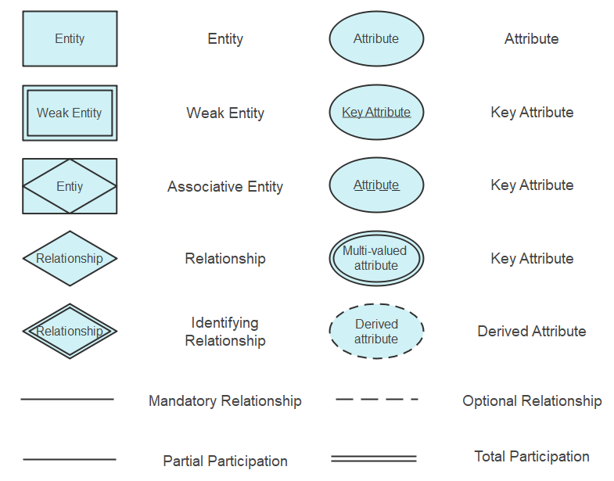

**Problem 1:**

The COMPANY database keeps track of a company’s employees, departments, and projects. Suppose that after the requirements collection and analysis phase, the database designers provide the following description of the miniworld—the part of the company that will be represented in the database.

* The company is organized into departments. Each department has a unique name, a unique number, and a particular employee who manages the department. We keep track of the start date when that employee began managing the department. A department may have several locations.
* A department controls a number of projects, each of which has a unique name, a unique number, and a single location.
* We store each employee’s name, Social Security number,address, salary, sex (gender), and birth date. An employee is assigned to one department, but may work on several projects, which are not necessarily controlled by the same department. We keep track of the current number of hours per week that an employee works on each project. We also keep track of the direct supervisor of each employee (who is another employee).
* We want to keep track of the dependents of each employee for insurance purposes. We keep each dependent’s first name, sex, birth date, and relationship to the employee.

**Problem 2:**

The Library Management System database keeps track of readers with the following considerations –

* The system keeps track of the staff with a single point authentication system comprising login Id and password.
* Staff maintains the book catalog with its ISBN, Book title, price(in INR), category(novel, general, story), edition, author Number and details.
* A publisher has publisher Id, Year when the book was published, and name of the book
* Readers are registered with their user_id, email, name (first name, last name), Phone no (multiple entries allowed), communication address. The staff keeps track of readers.
* Readers can return/reserve books that stamps with issue date and return date. If not returned within the prescribed time period, it may have a due date too.
* Staff also generate reports that has readers id, registration no of report, book no and return/issue info.  
    
  Q1) COMPANY_DATABASE   
  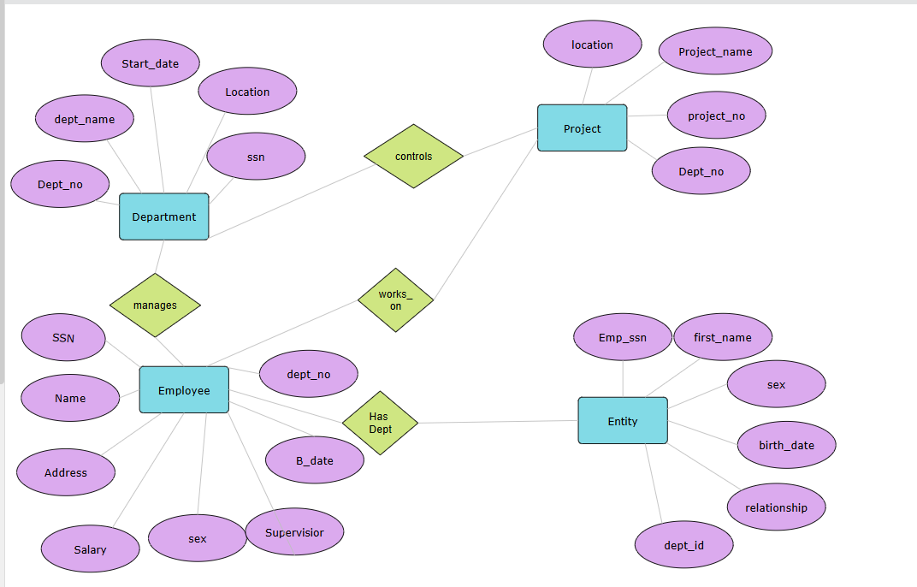  
  Q2) LIBRARY_MANAGEMENT  
  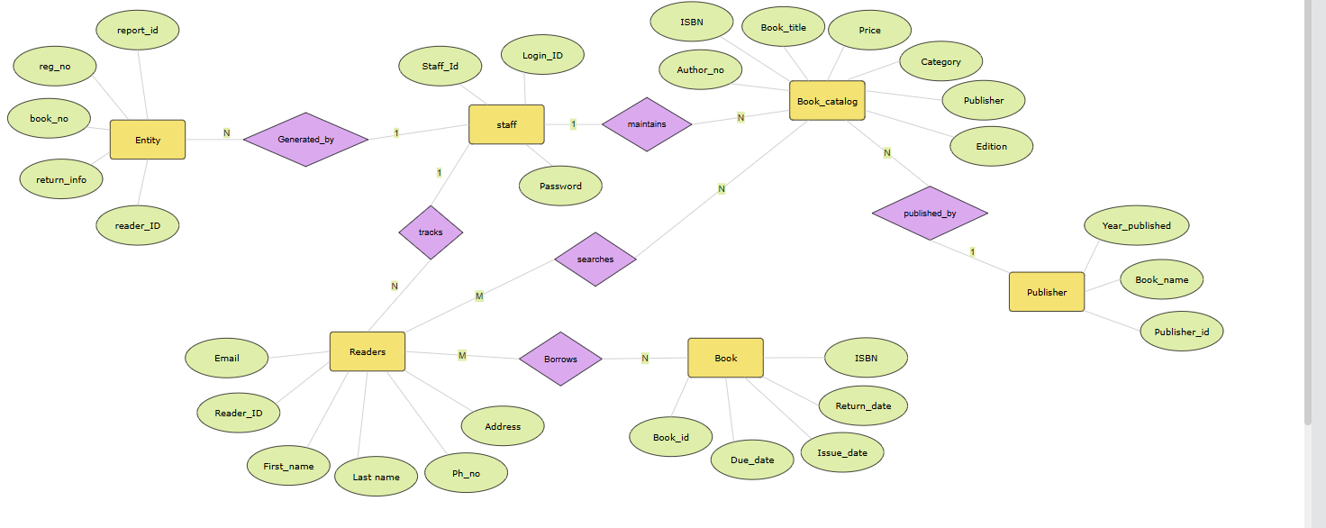

**Question :**

1. Draw ER diagrams for both problem description

2. Draw Database Schema

3. Define all 1.entities

                       2. Relationships types

                       3. Mappings

**RESULT**

Studied and implemented to design a database schema for an application with ER diagram from a problem description

**EXP NO: 2**

**Creation, modification, configuration, and deletion of databases Commands**

**AIM:**

To creation, modification, configuration, and deletion of databases using UI and SQL

Commands COMMANDS

**THEORY**

1. **CREATE DATABASE**

The CREATE DATABASE statement is used to create a new SQL database.

**SYNTAX**

CREATE DATABASE <*databasename*>

**EXAMPLE**

**Create database CMS**

## DROP DATABASE

The DROP DATABASE statement is used to drop an existing SQL database.

**SYNTAX**

DROP DATABASE  <*databasename*>

**EXAMPLE**

**Drop database CMS**

**3. USE DATABSE**

This will display the database created

**SYNTAX : Use <database name>**

**EXAMPLE : Use CMS**

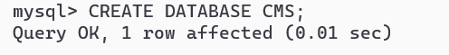

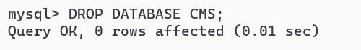

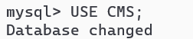

**Questions:**

1. **Create a database for company Management System(CMS)**

CREATE DATABASE CMS;

1. **Drop database**

DROP DATABASE CMS;

1. **Use database**

USE CMS;

**RESULT**

Studied and implementedCreation, modification, configuration, and deletion of databases using UI and SQL Commands

**EXP NO: 3**

**Applications of DDL Commands Using UI and SQL**

**Aim**

Creation of database schema - DDL (create tables, set constraints, enforce relationships, create indices, delete and modify tables).

**THEORY**

* + - 1. **CREATE TABLE**

The CREATE TABLE statement is used to create a new table in a database.

**SYNTAX**

CREATE TABLE *table_name*(  
*column1 datatype*,  
*column2 datatype*,  
*column3 datatype*,  
   ....  
);

* + - 1. **ALTER TABLE**

The ALTER TABLE statement is used to add, delete, or modify columns in an existing table.

The ALTER TABLE statement is also used to add and drop various constraints on an existing table.

**SYNTAX**

ALTER TABLE *table_name* ADD *column_name datatype*;

ALTER TABLE *table_name* DROP COLUMN *column_name*;

ALTER TABLE *table_name* RENAME COLUMN *old_name* to *new_name*;

* + - 1. **MODIFY TABLE**

ALTER TABLE *table_name* MODIFY COLUMN *column_name datatype*;

* + - 1. **DROP TABLE**

The DROP TABLE statement is used to drop an existing table in a database.

DROP TABLE *table_name*;

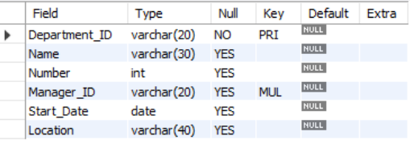

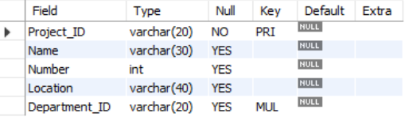

**5. TRUNCATE TABLE**

The TRUNCATE TABLE statement is used to delete the data inside a table, but not the table itself.

**1.** TRUNCATE TABLE *table_name*;

## SQL Constraints

SQL constraints are used to specify rules for the data in a table.

Constraints are used to limit the type of data that can go into a table. This ensures the accuracy and reliability of the data in the table. If there is any violation between the constraint and the data action, the action is aborted.

Constraints can be column level or table level. Column level constraints apply to a column, and table level constraints apply to the whole table.

The following constraints are commonly used in SQL:

* [NOT NULL](https://www.w3schools.com/sql/sql_notnull.asp) - Ensures that a column cannot have a NULL value
* [UNIQUE](https://www.w3schools.com/sql/sql_unique.asp) - Ensures that all values in a column are different
* [PRIMARY KEY](https://www.w3schools.com/sql/sql_primarykey.asp) - A combination of a NOT NULL and UNIQUE. Uniquely identifies each row in a table
* [FOREIGN KEY](https://www.w3schools.com/sql/sql_foreignkey.asp) - Prevents actions that would destroy links between tables
* [CHECK](https://www.w3schools.com/sql/sql_check.asp) - Ensures that the values in a column satisfies a specific condition
* [DEFAULT](https://www.w3schools.com/sql/sql_default.asp) - Sets a default value for a column if no value is specified
* [CREATE INDEX](https://www.w3schools.com/sql/sql_create_index.asp) - Used to create and retrieve data from the database very quickly
  + - 1. **Create following tables based on the description provided in Exp 1**

1. **Department Table:**

Attributes: DepartmentID (Primary Key), Name, Number, ManagerID (Foreign Key referencing Employee), StartDate, Location

create table Department_Table(Department_ID varchar(20) primary key,Name varchar(30),Number int,Manager_ID varchar(20),Start_Date Date,Location varchar(40));

1. **Project Table:** Attributes: ProjectID (Primary Key), Name, Number, Location, DepartmentID (Foreign Key referencing Department)

create table Project_Table(Project_ID varchar(20) primary key,Name varchar(30),Number int,Location varchar(40),Department_ID varchar(20));

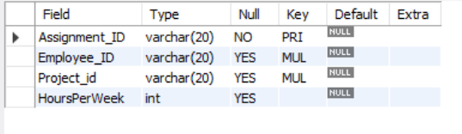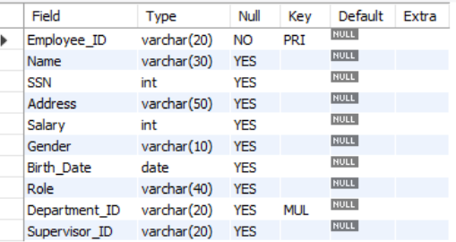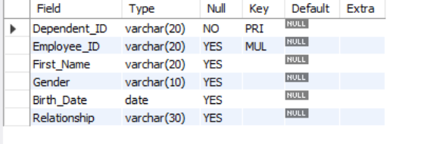

1. **Employee Table:**

Attributes: EmployeeID (Primary Key), Name, SSN, Address, Salary, Gender, BirthDate, Role, DepartmentID (Foreign Key referencing Department), SupervisorID (Foreign Key referencing Employee)

create table Employee_Table(Employee_ID varchar(20) primary key,Name varchar(30),SSN int,Address varchar(50),Salary int,Gender varchar(10),Birth_Date date,Role varchar(40),Department_ID varchar(20),Supervisor_ID varchar(20));

1. **ProjectAssignment Table:**

Attributes: AssignmentID (Primary Key), EmployeeID (Foreign Key referencing Employee), ProjectID (Foreign Key referencing Project), HoursPerWeek

create table Project_Assignment_Table(Assignment_ID varchar(20) primary key,Employee_ID varchar(20),Project_id varchar(20),HoursPerWeek int);

1. **Dependent Table:**

Attributes: DependentID (Primary Key), EmployeeID (Foreign Key referencing Employee), FirstName, Gender, BirthDate, Relationship

create table Dependent_Table(Dependent_ID varchar(20) primary key,Employee_ID varchar(20),First_Name varchar(20),Gender varchar(10),Birth_Date Date,Relationship varchar(30));

1. **Alter tables to add appropriate constraints**

alter table Department_Table add foreign key(Manager_ID) references

Employee_Table(Employee_ID);

alter table Project_Table add foreign key(Department_ID) references

Department_Table(Department_ID);

alter table Employee_Table add foreign key(Department_ID) references

Department_Table(Department_ID);

alter table Project_Assignment_Table add foreign key(Employee_ID) references

Employee_Table(Employee_ID),add foreign key(Project_ID) references

Project_Table(Project_ID);

alter table Dependent_Table add foreign key(Employee_ID) references

Employee_Table(Employee_ID);

**RESULT**

**Studied and implemented -creation of database schema-DDL**

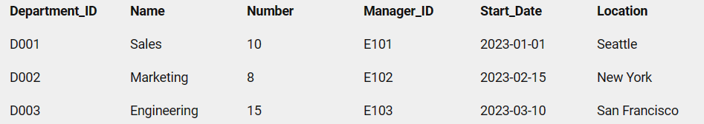

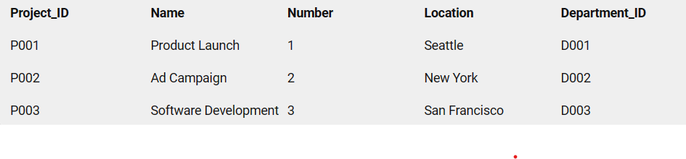

**EXP NO: 4**

**Database initialization - Data insert, Data import to a database (bulk import using UI and SQL Commands).**

**AIM**

To insert data to tables used in experiment no 3 using insert commands and bulk import using UI and sql commands.

**THEORY**

The INSERT INTO statement is used to insert new records in a table.

**INSERT:**

INSERT INTO *table_name* (*column1*,*column2*,*column3*,.)  
VALUES (*value1*,*value2*,*value3*, ...);

INSERT INTO *table_name*  
VALUES (*value1*,*value2*,*value3*, ...);

**QUERIES**

**Insert appropriate values to all tables created in Exp No. 3**

* INSERT INTO Department_Table (Department_ID, Name, Number, Manager_ID, Start_Date, Location) VALUES

('D001', 'Sales', 10, 'E101', '2023-01-01', 'Seattle'),

('D002', 'Marketing', 8, 'E102', '2023-02-15', 'New York'),

('D003', 'Engineering', 15, 'E103', '2023-03-10', 'San Francisco');

* INSERT INTO Project_Table (Project_ID, Name, Number, Location, Department_ID)

VALUES

('P001', 'Product Launch', 1, 'Seattle', 'D001'),

('P002', 'Ad Campaign', 2, 'New York', 'D002'),

('P003', 'Software Development', 3, 'San Francisco', 'D003');

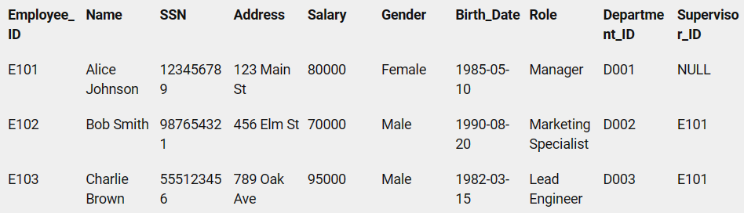

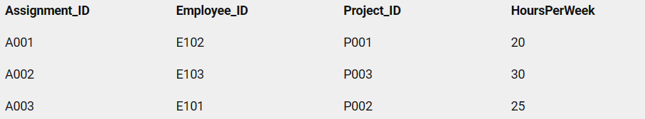

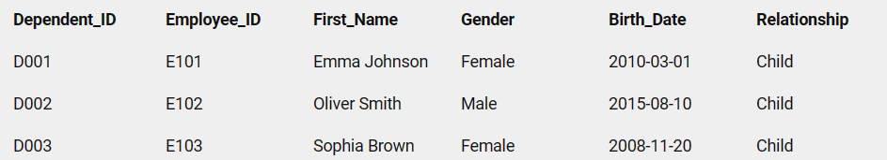

* INSERT INTO Employee_Table (Employee_ID, Name, SSN, Address, Salary, Gender, Birth_Date, Role, Department_ID, Supervisor_ID)

VALUES

('E101', 'Alice Johnson', 123456789, '123 Main St', 80000, 'Female', '1985-05-10', 'Manager', 'D001', NULL),

('E102', 'Bob Smith', 987654321, '456 Elm St', 70000, 'Male', '1990-08-20', 'Marketing Specialist', 'D002', 'E101'),

('E103', 'Charlie Brown', 555123456, '789 Oak Ave', 95000, 'Male', '1982-03-15', 'Lead Engineer', 'D003', 'E101');

* INSERT INTO Project_Assignment_Table (Assignment_ID, Employee_ID, Project_ID, HoursPerWeek)

VALUES

('A001', 'E102', 'P001', 20),

('A002', 'E103', 'P003', 30),

('A003', 'E101', 'P002', 25);

* INSERT INTO Dependent_Table (Dependent_ID, Employee_ID, First_Name, Gender, Birth_Date, Relationship)

VALUES

('D001', 'E101', 'Emma Johnson', 'Female', '2010-03-01', 'Child'),

('D002', 'E102', 'Oliver Smith', 'Male', '2015-08-10', 'Child'),

('D003', 'E103', 'Sophia Brown', 'Female', '2008-11-20', 'Child');

**RESULT**

**Studied and implemented database initialization- data insert,import data.**

**EXP NO: 5**

**DML Commands**

**AIM**

Practice SQL commands for DML (insertion, updating, altering, deletion of data, and viewing/querying records based on condition in databases)

**THEORY**

**SELECT:**

* + 1. SELECT *column1*,*column2, ..* FROM *table_name*;
    2. SELECT DISTINCT *column1*,*column2, ...* FROM *table_name*; (Shows only unique rows)
    3. SELECT *column1*,*column2, ...* FROM *table_name*  
       WHERE *condition*; (Where is used to filter records)
    4. SELECT *column1*,*column2, ...* FROM *table_name*  
       ORDER BY *column1, column2, ...*ASC|DESC**INSERT :**

( will sort the columns in ascending or descending order)

* + 1. SELECT *column1, column2, ...* FROM *table_name*  
       WHERE *columnN* LIKE *pattern*;

**UPDATE:**

PDATE *table_name* SET *column1*=*value1*,*column2*=*value2*, ...  
WHERE *condition*;

**DELETE:**

* + - 1. DELETE FROM *table_name*WHERE *condition*;

+-------+-------+

**1**| empid | ename |

+-------+-------+

| 101 | eli |

| 102 | asha |

| 103 | arya |

| 104 | diya |

+-------+-------+

+-------+-------+------------+

**2**| empid | ename | address |

+-------+-------+------------+

| 1 | eli | pune |

| 2 | asha | kolkata |

| 3 | arya | hydrabad |

+-------+-------+------------+

**3** +-------+-------+------------+-----------+

| empid | ename | address | role |

+-------+-------+------------+-----------+

| 1 | eli | pune | hr exec |

| 2 | asha | kolkata | manager |

| 3 | arya | hydrabad | assistant |

| 4 | diya | malayatoor | ceo |

**4** +-------+-------+--------+

| empid | ename | salary |

+-------+-------+--------+

| 1 | eli | 90000 |

| 2 | asha | 40000 |

| 3 | arya | 55000 |

| 4 | diya | 70000 |

+-------+-------+--------+

**5.**

+-------+-------+------+---------+--------+--------+-----------+---------+

| empid | ename | ssn | address | salary | gender | birthdate | role |

+-------+-------+------+---------+--------+--------+-----------+---------+

| 2 | asha | 37 | kolkata | 40000 | F |12-03-2004 | manager |

+-------+-------+------+---------+--------+--------+-----------+---------+

**6.**

+-------+-------+--------+

| empid | ename | salary |

+-------+-------+--------+

| 101 | eli | 110000 |

| 104 | diya | 70000 |

+-------+-------+--------+

**Algorithm:**

**Consider the employee database created. Find the following**

* + - 1. **Find the names of all employees who work for SBI.**

Select * from Emp where cname= ‘SBI’;

**2)Find all employees in the database who live in the same cities as the companies for which they work.**

Select * from Emp WHERE address=pune,Kolkata,hydrabad;

**3)Find all employees and their managers in the database who live in the same cities and on the same street number as do their managers.**

Select empid,ename,address,role from Emp;

**4)Find all employees who earn more than the average salary of all employees of their company.**

Select ename from Emp where salary>avg(salary);

**5)Find the company that pays the least total salary along with the salary paid.**

Select * FROM Emp WHERE salary = (SELECT MIN(salary) FROM Emp);

**6)Give all managers of SBI a 10 percent raise.**

Select ename,salary+(salary*0.1) from Emp;

7.

+-------+--------+

| count |company |

+-------+--------+

| 4 |infosis |

+------+--------+

8.

+-------+--------+

| cname | salary |

+-------+--------+

|infosis| 110000 |

|infopark| 60000 |

+-------+--------+

**9.**

+--------+----------------+

| deptid | dname |

+--------+----------------+

| 1 | design |

| 2 | administration |

| 3 | sales |

| 4 | sales |

+--------+----------------+

**10.**

+-------+-------+

| empid | ename |

+-------+-------+

| 101 | eli |

| 102 | asha |

| 104 | diya |

+-------+-------+

**7)Find the company that has the most employees**

SELECT COUNT(*) FROM employees;

**8)Find those companies whose employees earn a higher salary, on average than the average salary at Indian Bank.**

SELECT t1.CName, t2.AvgSalary

FROM Company t1

INNER JOIN (SELECT AVG(Salary) AS AvgSalary,CID FROM Works GROUP BY CID) t2 ON t1.CID = t2.CID

WHERE t2.AvgSalary > (SELECT AVG(Salary) FROM blog.Works t1a INNER JOIN blog.Company t2a ON t1a.cid = t2a.cid WHERE t2a.cname = 'indian bank');

**9)Change the department of one employee to another.**

Update dept set dname=design where deptid=1;

**10)Remove employee with ID 203 from the database.**

Delete from Emp where empid=103;

**RESULT**

**Thus the DML was performed successfully and executed.**

**EXP NO: 6**

**Implementation of Built In Functions**

**AIM**:

Implementation of built in functions in RDBMS

# Theory

**RDBMS Built in Functions**

There are two types of functions:

1) **Single Row Functions:** Single row or Scalar functions return a value for every row that is processed in a query.

2) **Group Functions:** These functions group the rows of data based on the values returned by the query. This is discussed in SQL GROUP Functions. The group functions are used to calculate aggregate values like total or average, which return just one total or one average value after processing a group of rows.

There are four types of single row functions. They are:

**1)** **Numeric Functions:** These are functions that accept numeric input and return numeric values.

**2)** **Character or Text Functions:** These are functions that accept character input and can return both character and number values.

**3)** **Date Functions:** These are functions that take values that are of datatype DATE as input and return values of datatype DATE, except for the MONTHS_BETWEEN function, which returns a number.

**4)** **Conversion Functions:** These are functions that help us to convert a value in one form to another form. For Example: a null value into an actual value, or a value from one datatype to another datatype like NVL, TO_CHAR, TO_NUMBER, TO_DATE etc.

You can combine more than one function together in an expression. This is known as nesting of functions.

# 

# 1. Numeric Functions:

Numeric functions are used to perform operations on numbers. They accept numeric values as input and return numeric values as output. Few of the Numeric functions are:

| **Function Name** | **Return Value** |
| --- | --- |
| ABS (x) | Absolute value of the number '*x*' |
| CEIL (x) | Integer value that is Greater than or equal to the number '*x*' |
| FLOOR (x) | Integer value that is Less than or equal to the number '*x*' |
| TRUNC (x, y) | Truncates value of number '*x*' up to '*y*' decimal places |
| ROUND (x, y) | Rounded off value of the number '*x*' up to the number '*y*' decimal places |

The following examples explains the usage of the above numeric functions :

| **Function Name** | **Examples** | **Return Value** |
| --- | --- | --- |
| ABS (x) | ABS (1) | 1 |
|  | ABS (-1) | -1 |
|  | CEIL (2.83) | 3 |
| CEIL (x) | CEIL (2.49) | 3 |
|  | CEIL (-1.6) | -1 |
|  | FLOOR (2.83) | 2 |
| FLOOR (x) | FLOOR (2.49) | 2 |
|  | FLOOR (-1.6) | -2 |
|  | ROUND (125.456, 1) | 125.4 |
| ROUND (x, y) | ROUND (125.456, 0) | 125 |
|  | ROUND (124.456, -1) | 120 |

# 

# 2. Character or Text Functions:

Character or text functions are used to manipulate text strings. They accept strings or characters as input and can return both character and number values as output.

Few of the character or text functions are as given below:

| **Function Name** | **Return Value** |
| --- | --- |
| LOWER (string_value) | All the letters in ***'string_value'*** is converted to lowercase. |
| UPPER (string_value) | All the letters in ***'string_value'*** is converted to uppercase. |
| LTRIM (string_value, trim_text) | All occurrences of ***'trim_text'*** is removed from the left of  ***'string_value'***. |
| RTRIM (string_value, trim_text) | All occurrences of ***'trim_text'*** is removed from the right of  ***'string_value'*** . |
| TRIM (trim_text FROM string_value) | All occurrences of ***'trim_text'*** from the left and right of  ***'string_value'*** , ***'trim_text'*** can also be only one character long . |
| SUBSTR (string_value, m, n) | Returns ***'n'*** number of characters from ***'string_value'***  starting from the '***m'*** position. |
| LENGTH (string_value) | Number of characters in *'string_value'* in returned. |
| LPAD (string_value, n, pad_value) | Returns '*string_value'* left-padded with *'pad_value'* . The  length of the whole string will be of *'n'* characters. |
| RPAD (string_value, n, pad_value) | Returns '*string_value'* right-padded with *'pad_value'* . The length  of whole string will be of ‘n’ characters. |

For Example, we can use the above UPPER() text function with the column value as follows. SELECT UPPER (product_name) FROM product;

The following examples explains the usage of the above character or text functions

| Function Name | Examples | Return Value |
| --- | --- | --- |
| LOWER(string_value) | LOWER('Good Morning') | good morning |
| UPPER(string_value) | UPPER('Good Morning') | GOOD MORNING |

| INITCAP(string_value) | INITCAP('GOOD MORNING') | Good Morning |
| --- | --- | --- |
| LTRIM(string_value, trim_text) | LTRIM ('Good Morning', 'Good) | Morning |
| RTRIM (string_value, trim_text) | RTRIM ('Good Morning', '  Morning') | Good |
| TRIM (trim_text FROM string_value) | TRIM ('o' FROM 'Good Morning') | Gd Mrning |
| SUBSTR (string_value, m, n) | SUBSTR ('Good Morning', 6, 7) | Morning |
| LENGTH (string_value) | LENGTH ('Good Morning') | 12 |
| LPAD (string_value, n, pad_value) | LPAD ('Good', 6, '*') | **Good |
| RPAD (string_value, n, pad_value) | RPAD ('Good', 6, '*') | Good** |

**3. Date Functions:**

These are functions that take values that are of datatype DATE as input and return values of datatypes DATE, except for the MONTHS_BETWEEN function, which returns a number as output.

Few date functions are as given below:

| Function Name | Return Value |
| --- | --- |
| ADD_MONTHS (date, n) | Returns a date value after adding *'n'* months to the date *'x'*. |
| MONTHS_BETWEEN (x1, x2) | Returns the number of months between dates x1 and x2. |
| ROUND (x, date_format) | Returns the date *'x'* rounded off to the nearest century, year, month, date, hour, minute, or second as specified by the *'date_format'*. |
| TRUNC (x, date_format) | Returns the date *'x'* lesser than or equal to the nearest century, year, month, date, hour, minute, or second as specified by the 'date_format'. |
| NEXT_DAY (x, week_day) | Returns the next date of the *'week_day'* on or after the date  *'x'* occurs. |

| LAST_DAY (x) | It is used to determine the number of days remaining in a  month from the date *'x'* specified. |
| --- | --- |

| SYSDATE | Returns the systems current date and time. |
| --- | --- |
| NEW_TIME (x, zone1, zone2) | Returns the date and time in zone2 if date 'x' represents the  time in zone1. |

The below table provides the examples for the above functions

| Function Name | Examples | Return Value |
| --- | --- | --- |
| ADD_MONTHS ( ) | ADD_MONTHS ('16-Sep-81', 3) | 16-Dec-81 |
| MONTHS_BETWEEN( ) | MONTHS_BETWEEN('16-Sep-81',  '16-Dec-81') | 3 |
| NEXT_DAY( ) | NEXT_DAY ('01-Jun-08', 'Wednesday') | 04-JUN-08 |
| LAST_DAY( ) | LAST_DAY ('01-Jun-08') | 30-Jun-08 |
| NEW_TIME( ) | NEW_TIME ('01-Jun-08', 'IST', 'EST') | 31-May-08 |

Conversion Functions:

These are functions that help us to convert a value in one form to another form. For Ex: a null value into an actual value, or a value from one datatype to another datatype like NVL, TO_CHAR, TO_NUMBER, TO_DATE.

| Function Name | Return Value |
| --- | --- |
| TO_CHAR (x [,y]) | Converts Numeric and Date values to a character string value. It  cannot be used for calculations since it is a string value. |
| TO_DATE (x [, date_format]) | Converts a valid Numeric and Character values to a Date value.  Date is formatted to the format specified by *'date_format'*. |
| NVL (x, y) | If *'x'* is NULL, replace it with *'y'*. *'x'* and *'y'* must be of the same  datatype. |
| DECODE(a, b, c, d, e,  default_value) | Checks the value of *'a'*, if *a = b*, then returns *'c'*. If *a = d*, then returns *'e'*. Else, returns *default_value*. |

Few of the conversion functions available in oracle are:

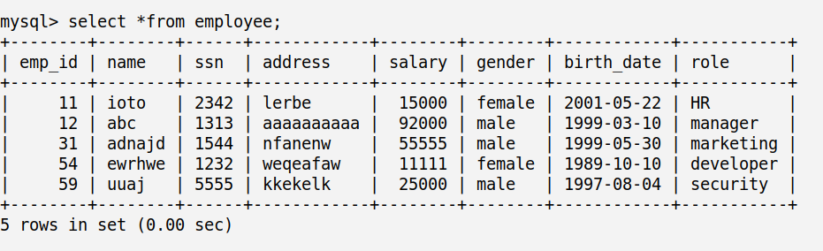

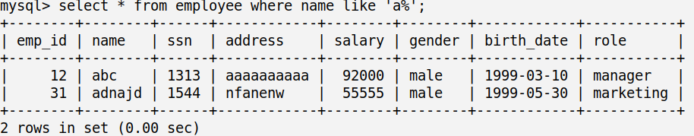

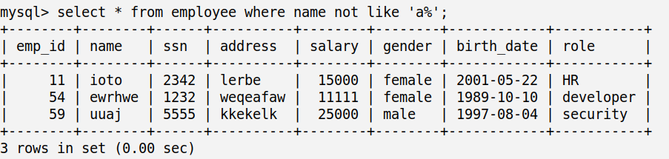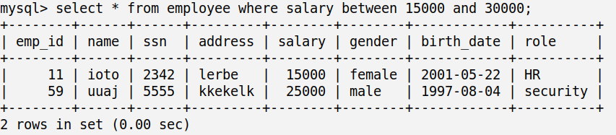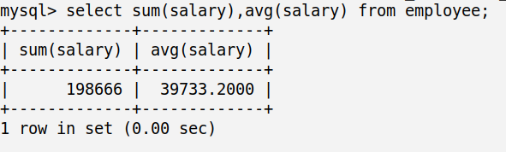

The below table provides the examples for the above functions

| Function Name | Examples | Return Value |
| --- | --- | --- |
| TO_CHAR () | TO_CHAR (3000, '$9999')  TO_CHAR (SYSDATE, 'Day, Month YYYY') | $3000  Monday, June 2008 |
| TO_DATE () | TO_DATE ('01-Jun-08') | 01-Jun-08 |
| NVL () | NVL (null, 1) | 1 |
|  |  |  |

Queries:

# Q1: Display all the details of the records whose employee name starts with ‘A’. Solution:

select * from employee where name like ‘%a’;;

# 

# Q2: Display all the details of the records whose employee name does not start with ‘A’.

select *from employee where name not like ‘a%’;

# Q3: Display the rows whose salary ranges from 15000 to 30000.

select * from employee where salary between 15000 and 300000;

# Q4: Calculate the total and average salary amount of the emp table.

select sum(salary),avg(salary) from employee;

# 

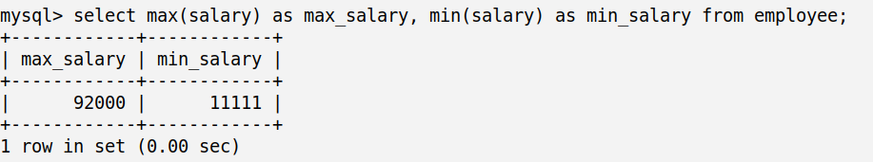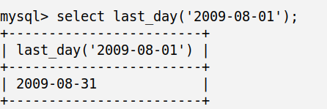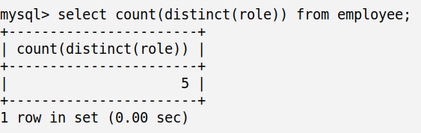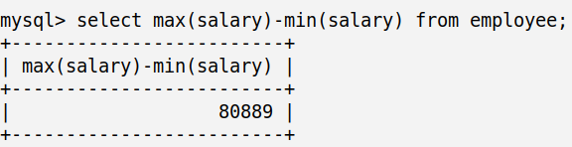

# Q5: Count the total records in the emp table.

Select count(*) from employee;

# Q6: Determine the max and min salary and rename the column as max_salary and min_salary.

Select max(salary) as max_salary,min(salary) as min_salary from employee;

# Q7: Display the last day of that month in “05-Oct-09”.

Select last_day(‘2009-08-01’);

**Q8**: **Find how many job titles are available in the employee table.**

select count(distinct(role)) from employee;

# Q9: What is the difference between maximum and minimum salaries of employees in the organization?

# Select max(salary)-min(salary) from employee;

# RESULT

Thus the nested Queries and join Queries were performed successfully and executed.

**EXP NO: 7**

**Implementation of various aggregate functions in SQL**

# Aim:

Implementation of various aggregate functions in SQL

# Theory:

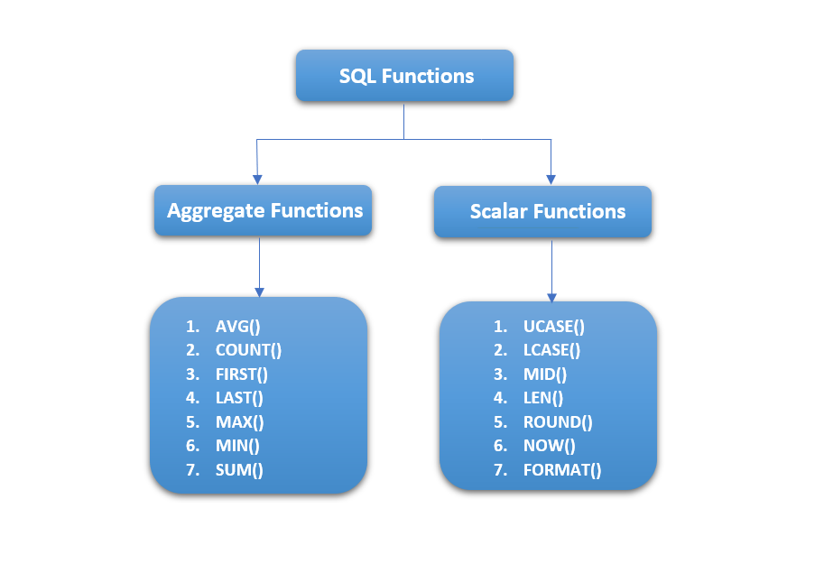

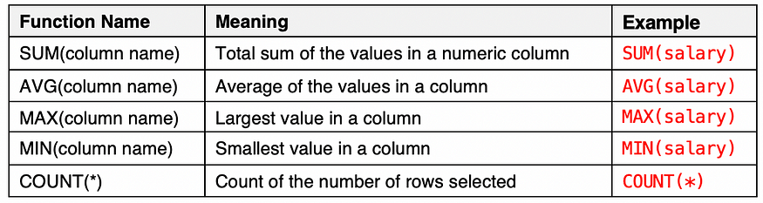

SELECT COUNT(*column_name*) FROM *table_name* WHERE *condition*;

SELECT AVG(*column_name*) FROM *table_name* WHERE *condition*;

SELECT SUM(*column_name*) FROM *table_name* WHERE *condition*;

SELECT MIN(*column_name*) FROM *table_name* WHERE *condition*;

SELECT MAX(*column_name*) FROM *table_name* WHERE *condition*;

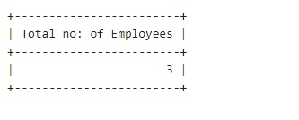

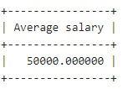

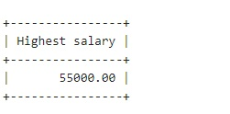

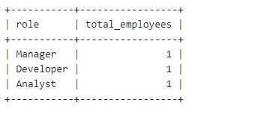 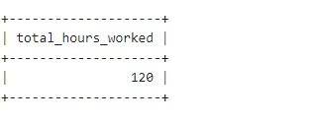

**QUERIES**

* + - 1. **Count the total number of employees.**

SELECT COUNT(Empid) as” Total no of Employees “FROM Employee;

* + - 1. **Find the average salary of all employees.**

SELECT AVG(Salary) as Total_Salary FROM Employee;

* + - 1. **Find the highest salary among all employees.**

SELECT MAX(salary) as Highest_Salary FROM Employee;

* + - 1. **Count the number of employees in each role.**

SELECT role, COUNT(*) AS total_employees

FROM employees

GROUP BY role;

* + - 1. **Calculate the overall sum of hours worked on projects.**

SELECT SUM(HoursPerWeek) AS total_hours_worked

FROM ProjectAssignment;

* + - 1. **Count the total number of projects.**

SELECT COUNT(ProjectID) AS total_projects

FROM Project;

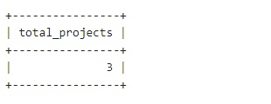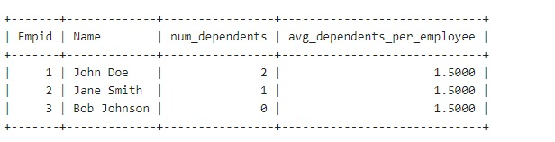

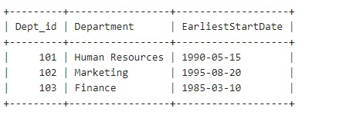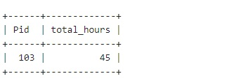

* + - 1. **Calculate the average number of dependents for each employee.**

SELECT e.Eid, e.Name,

(SELECT COUNT(*) FROM Dependents d WHERE d.Eid = e.Eid) AS num_dependents, (SELECT AVG(dependent_count) FROM (SELECT COUNT(*) AS dependent_count FROM Dependents GROUP BY Eid) AS avg_dependents) AS avg_dependents_per_employee

FROM Employee;

* + - 1. **Find the project with the highest total hours worked.**

SELECT Pid, total_hours FROM (

SELECT Pid, SUM(HoursPerWeek) AS total_hours FROM ProjectAssignment

GROUP BY Pid) AS ProjectHours WHERE total_hours = (SELECT MAX(total_hours) FROM (

SELECT SUM(HoursPerWeek) AS total_hoursFROM ProjectAssignment

GROUP BY Pid) AS MaxProjectHours);

**9.Find the earliest start date of employees in each department.**

SELECT D.Dept_id, D.Name AS Department, MIN(E.Birthdate) AS EarliestStartDate

FROM Department D JOIN Employee E ON D.Dept_id = E.Did

GROUP BY D.Dept_id, D.Name;

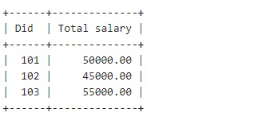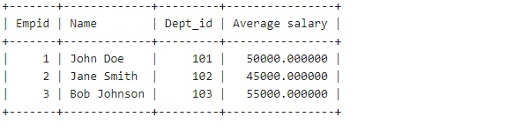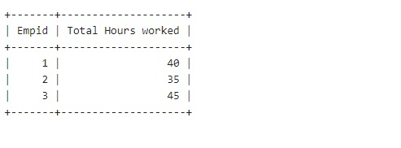

**10.Retrieve the total salary spent by each department.**

SELECT Did, SUM(Salary) as “Total salary” FROM Employee

GROUP BY Did;

**11.Average Salary of Employees in Each Department:**

SELECT E.Empid, E.Name, D.Dept_id, AVG(E.Salary) as "Average salary"

FROM Employee E

JOIN Department D ON E.Did = D.Dept_id

GROUP BY E.Empid, E.Name, D.Dept_id;

**12.Calculate the total hours worked on projects by each employee.**

SELECT Empid, SUM(HoursPerWeek) as "Total Hours worked" FROM ProjectAssignment

GROUP BY Empid;

**RESULT**

Studied and implemented various aggregate functions in SQL.

**EXP NO: 8**

**Implementation of Order By, Group By & Having clause**

**AIM**

Implementation of Order By, Group By & Having clause

**THEORY**

**GROUP BY**

The GROUP BY statement groups rows that have the same values into summary rows, like "find the number of customers in each country".

The GROUP BY statement is often used with aggregate functions (COUNT(), MAX(), MIN(), SUM(), AVG()) to group the result-set by one or more columns.

SELECT *column_name(s)* FROM *table_name*  
WHERE *condition*  
GROUP BY *column_name(s)*ORDER BY *column_name(s);*

Example: SQL> SELECT EMPNO, SUM (SALARY) FROM EMP GROUP BY EMPNO;

**GROUP BY-HAVING :**

The HAVING clause was added to SQL because the WHERE keyword could not be used with aggregate functions. The HAVING clause must follow the GROUP BY clause in a query and must also precede the ORDER BY clause if used.

SELECT *column_name(s)*  
FROM *table_name*  
WHERE *condition*  
GROUP BY *column_name(s)*HAVING *condition*ORDER BY *column_name(s);*

Example : SELECT COUNT(CustomerID), Country FROM Customers  
GROUP BY Country HAVING COUNT(CustomerID) > 5;

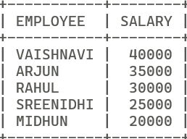

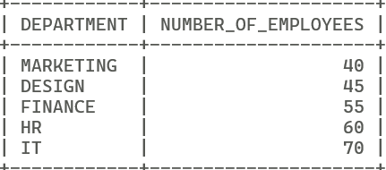

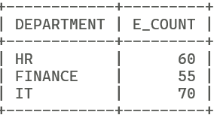

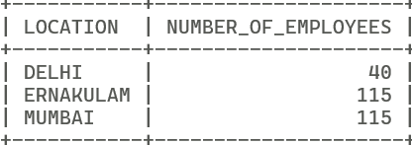

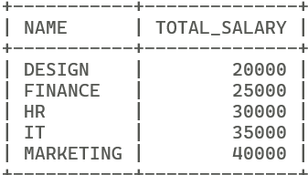

**ORDER BY:**

This query is used to display a selected set of fields from a relation in an ordered manner based on some field.

SELECT *column1*,*column2, ...*  
FROM *table_name*  
ORDER BY *column1, column2, ...*ASC|DESC;

Example: SQL> SELECT empno, ename, job FROM emp ORDER BY job;

**QUESTIONS**

1. **Order Employees by Salary in Descending Order**

SELECT NAME AS EMPLOYEE,SALARY FROM EMPLOYEE ORDER BY SALARY DESC;

**2.Order Companies by Total Employees in Ascending Order**

SELECT NAME AS DEPARTMENT,E_COUNT AS NUMBER_OF_EMPLOYEES FROM DEPARTMENT ORDER BY E_COUNT;

**3.Find Companies with More Than 50 Employees**

SELECT NAME AS DEPARTMENT,E_COUNT FROM DEPARTMENT WHERE E_COUNT>50;

**4.Count the number of employees in each city.**

SELECT LOCATION ,SUM(E_COUNT) AS NUMBER_OF_EMPLOYEES FROM DEPARTMENT GROUP BY(LOCATION);

**5.Find the total salary paid by each company**

SELECT D.NAME,SUM(E.SALARY) AS TOTAL_SALARY FROM DEPARTMENT D INNER JOIN EMPLOYEE E ON D.DEPT_ID=E.DEPT_ID GROUP BY D.NAME;

**RESULT**

Studied and implementation of Order By, Group By& Having clause.

**Expt No 9**

**Implementation of set operators nested queries, and join queries**

**AIM**

Implementation of set operators nested queries, and join queries

**THEORY**

Set Operators And Nested Queries

A subQuery is a form of an SQL statement that appears inside another SQL statement. It is also termed as a nested Query. The statement contains a subQuery called a parent statement. The rows returned by the subQuery are used by the following statement.

**Union Clause:**

The user can put together multiple Queries and combine their output using the union clause . The union clause merges the output of two or more Queries into a single set of rows and columns. The final output of union clause will be

Output: = Records only in Query one + records only in Query two + A single set of records which are common in both Queries.

Syntax:

SELECT columnname, columname FROM tablename 1 UNION SELECT columnname, columnname From tablename2;

**Intersect Clause:**

The user can put together multiple Queries and their output using the interest clause.

The final output of the interest clause will be : A single set of records which are common in both Queries

SELECT columnname, columnname FROM tablename 1 INTERSECT

SELECT columnname, columnname FROM tablename 2;

**Minus Clause:**

The user can put together multiple Queries and combine their output

Output:= records only in Query one

Syntax:

SELECT columnname, columnname FROM tablename 1 MINUS

SELECT columnname, columnname FROM tablename 2

**Join queries**

Joint Multiple Table (Equi Join): Sometimes we require to treat more than one table as though to manipulate data from all the tables as though the tables were not separate objects but one single entity. To achieve this we have to join tables. Tables are joined on columns that have data type and data within tables.

The tables that have to be joined are specified in the FROM clause and the joining attributes in the WHERE clause.

* + - 1. **Cartesian product/Cross Join**

The CROSS JOIN keyword returns all records from both tables (table1 and table2).

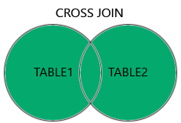

**CROSS JOIN Syntax**

SELECT *column_name(s)* FROM *table1*  
CROSS JOIN *table2*;

* + - 1. **Inner Join:**

The INNER JOIN keyword selects records that have matching values in both tables.

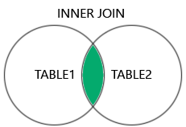

**INNER JOIN Syntax**

SELECT *column_name(s)*  
FROM *table1*  
INNER JOIN *table2*ON *table1.column_name*=*table2.column_name*;

**3. Left Join:**

The LEFT JOIN keyword returns all records from the left table (table1), and the matching records (if any) from the right table (table2).

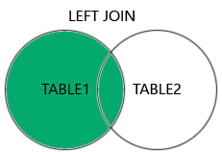

### LEFT JOIN Syntax

SELECT *column_name(s)*  
FROM *table1*  
LEFT JOIN *table2*ON *table1.column_name*=*table2.column_name*;

**4. Right Join:**

The RIGHT JOIN keyword returns all records from the right table (table2), and the matching records (if any) from the left table (table1).

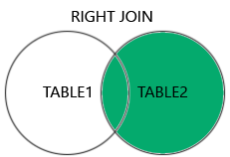

### RIGHT JOIN Syntax

SELECT *column_name(s)*  
FROM *table1*  
RIGHT JOIN *table2*ON *table1.column_name*=*table2.column_name*;

**Examples**

**Inner Join:**

**Retrieve the name of each employee along with the name of their department.**

SELECT *Employee.Name, Department.Name* FROM Employee

INNER JOIN *Department* ON *Employee.DepartmentID* = *Department.DepartmentID*;

**Cross Join:**

**2. Retrieve all possible combinations of employees and projects.**

SELECT *Employee.Name, Project.Name* FROM *Employee* CROSS JOIN *Project*;

**Left Join:**

**3. Retrieve all employees along with their assigned project names (if any).**

SELECT *Employee.Name, Project.Name* FROM *Employee*

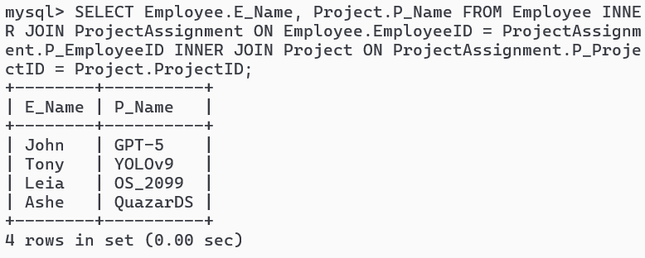

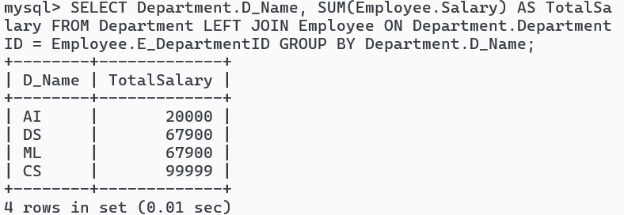

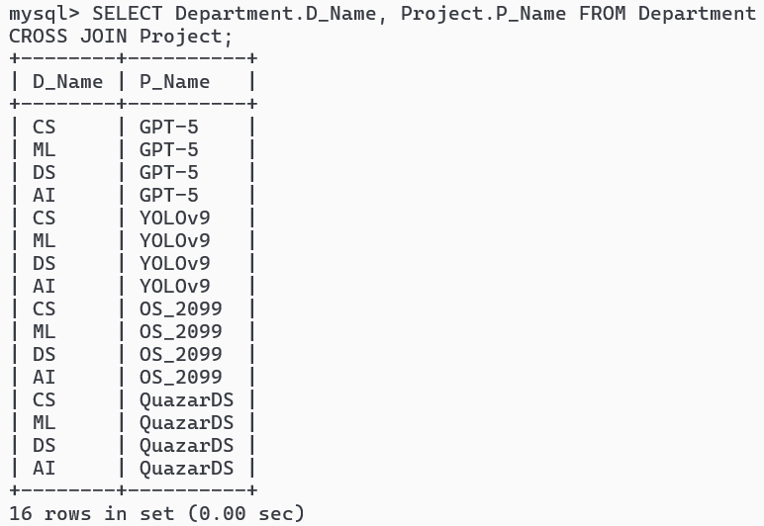

LEFT JOIN *ProjectAssignment* ON *Employee.EmployeeID = ProjectAssignment.EmployeeID*

LEFT JOIN Project ON *ProjectAssignment.ProjectID = Project.ProjectID*;

**Right Join:**

**4. Retrieve all projects along with the employees assigned to them (if any).**

SELECT *Project.Name, Employee.Name* FROM *Project*

RIGHT JOIN *ProjectAssignment* ON *Project.ProjectID = ProjectAssignment.ProjectID*

RIGHT JOIN Employee ON *ProjectAssignment.EmployeeID = Employee.EmployeeID*;

**QUESTIONS**

1. **Retrieve the names of employees and their corresponding project names for all employees who are currently assigned to a project.**
2. SELECT Employee.E_Name, Project.P_Name FROM Employee INNER JOIN ProjectAssignment ON Employee.EmployeeID = ProjectAssignment.P_EmployeeID INNER JOIN Project ON ProjectAssignment.P_ProjectID = Project.ProjectID;

**2.Get the names of departments along with the total salary of employees in each department.**

SELECT Department.D_Name, SUM(Employee.Salary) AS TotalSalary FROM Department LEFT JOIN Employee ON Department.DepartmentID = Employee.E_DepartmentID GROUP BY Department.D_Name;

**3.Get a list of all department names along with all project names without any specific relationship.**

SELECT Department.D_Name, Project.P_Name FROM Department

CROSS JOIN Project;

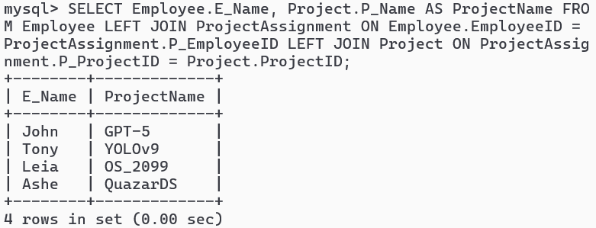

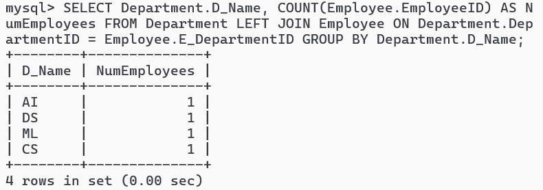

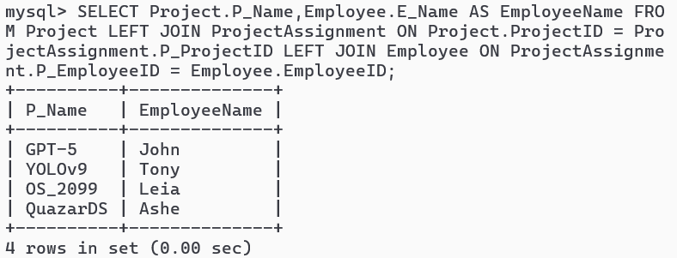

**4.List all employees and their assigned project names, including those who are not assigned to any project.**

SELECT Employee.E_Name, Project.P_Name AS ProjectName FROM Employee LEFT JOIN ProjectAssignment ON Employee.EmployeeID = ProjectAssignment.P_EmployeeID LEFT JOIN Project ON ProjectAssignment.P_ProjectID = Project.ProjectID;

**5.Show all departments and the number of employees in each department, even if there are no employees.**

SELECT Department.D_Name, COUNT(Employee.EmployeeID) AS NumEmployees FROM Department LEFT JOIN Employee ON Department.DepartmentID = Employee.E_DepartmentID GROUP BY Department.D_Name;

**6.Retrieve all project names and the names of employees assigned to them, including projects without any assigned employees.**

SELECT Project.P_Name,Employee.E_Name AS EmployeeName FROM Project LEFT JOIN ProjectAssignment ON Project.ProjectID = ProjectAssignment.P_ProjectID LEFT JOIN Employee ON ProjectAssignment.P_EmployeeID = Employee.EmployeeID;

**Result**

Studied and implemented set operators, nested queries and Join queries.

**EXP NO: 10**

**Practice of SQL TCL commands like Rollback, Commit, Savepoint**

**AIM**

Practice of SQL TCL commands like Rollback, Commit, Savepoint

**THEORY**

TRANSATIONAL CONTROL LANGUAGE (TCL): A transaction is a logical unit of work. All changes made to the database can be referred to as a transaction. Transaction changes can be mode permanent to the database only if they are committed a transaction begins with an executable SQL statement & ends explicitly with either role back or commit statement.

**COMMIT**

The basic syntax for using a COMMIT command in SQL is as follows :

*BEGIN;*

*{a set of SQL statements};*

*COMMIT;*

A more simplified version of syntax for other relational databases like MYSQL is as follows :

*{a set of SQL statements};*

*COMMIT;*

**SAVE POINT & ROLL BACK:**

Save points are like marks to divide a very lengthy transaction to smaller once. They are used to identify a point in a transaction to which we can latter role back. Thus, save point is used in conjunction with role back.

Syntax: SQL>SAVE POINT ID;

Example: SQL>SAVE POINT xyz;

**ROLL BACK:**

A role back command is used to undo the current transactions. We can role back the entire transaction so that all changes made by SQL statements are undo (or) role back a transaction to a save point so that the SQL statements after the save point are role back.

Syntax:

ROLE BACK( current transaction can be role back)

ROLE BACK to save point ID;

**Commit**

In MySQL, the statement SET autocommit=0; is used to disable the autocommit feature. By default, autocommit is **enabled**, which means that each SQL statement is automatically committed as a separate transaction.

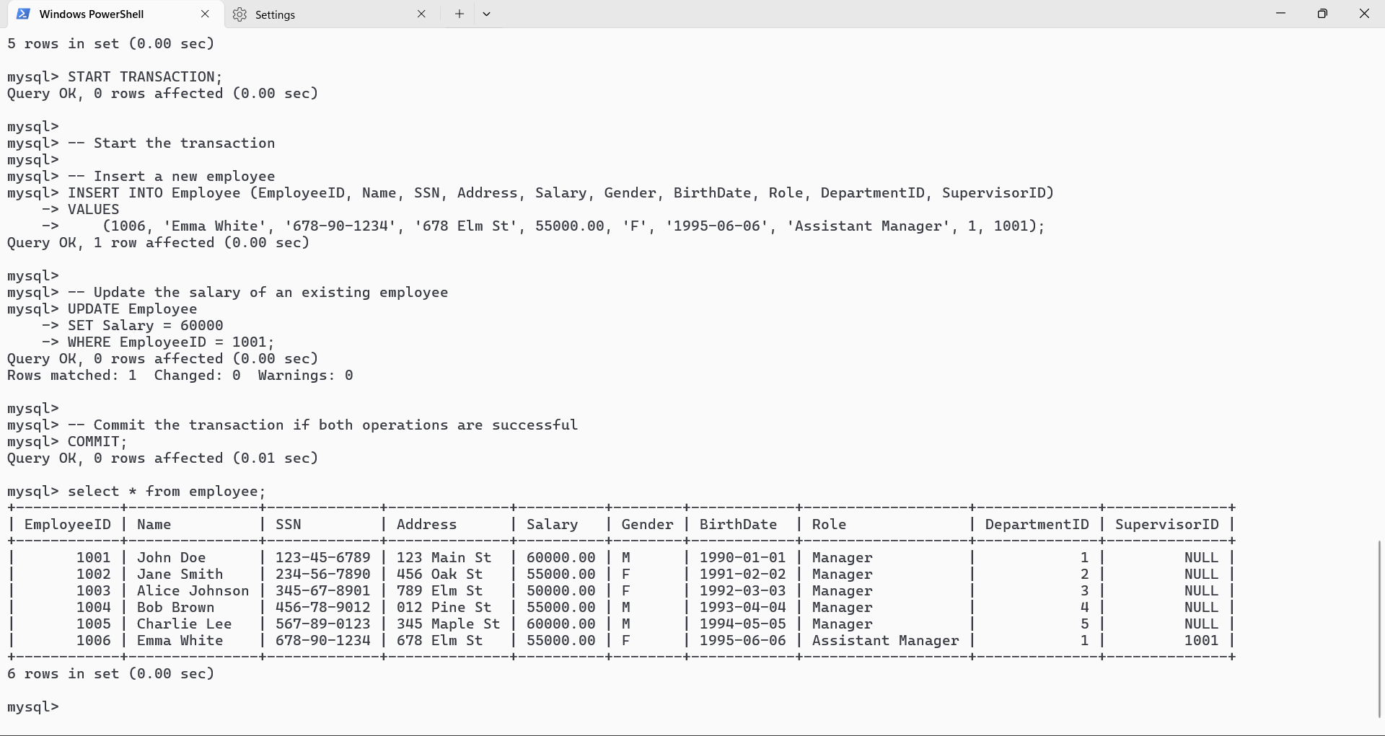

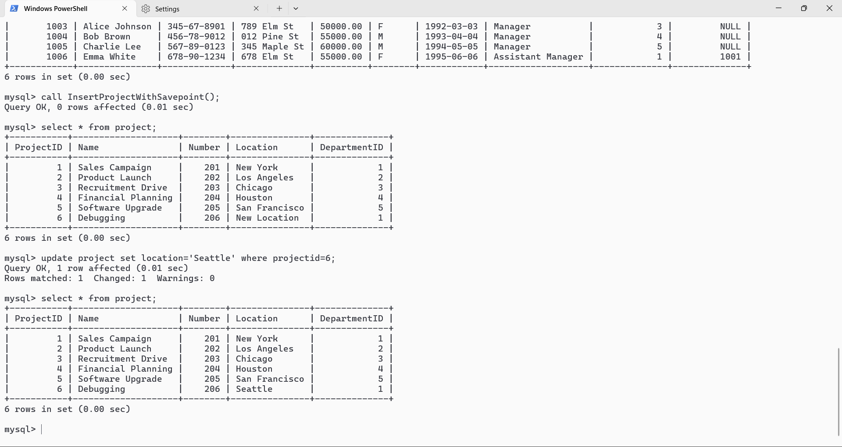

**\*/**

*SET autocommit=0;*

/*

**QUESTION 1: Create a transaction that inserts a new employee record and updates the salary of an existing employee. Ensure that both operations are successful before committing the transaction."**

START TRANSACTION;

INSERT INTO Employee (EmployeeID, Name, SSN, Address, Salary, Gender, BirthDate, Role, DepartmentID, SupervisorID) VALUES (1006, 'Emma White', '678-90-1234', '678 Elm St', 55000.00, 'F', '1995-06-06', 'Assistant Manager', 1, 1001);

UPDATE Employee SET Salary = 60000 WHERE EmployeeID = 1001;

COMMIT;

**QUESTION 2:** **Within a transaction, create a savepoint after inserting a new project. Rollback to the savepoint if an error occurs during subsequent operations**

DELIMITER //

CREATE PROCEDURE InsertProjectWithSavepoint()

BEGIN

DECLARE error_occurred BOOLEAN DEFAULT FALSE;

START TRANSACTION;

INSERT INTO Project (ProjectID, Name, Number, Location, DepartmentID)

VALUES (6, 'Debugging', 206, 'Seattle', 1);

SAVEPOINT after_project_insert;

BEGIN

DECLARE CONTINUE HANDLER FOR SQLEXCEPTION SET error_occurred := TRUE;

END;

IF error_occurred THEN

ROLLBACK TO after_project_insert;

ELSE

COMMIT;

END IF;

END//

DELIMITER ;

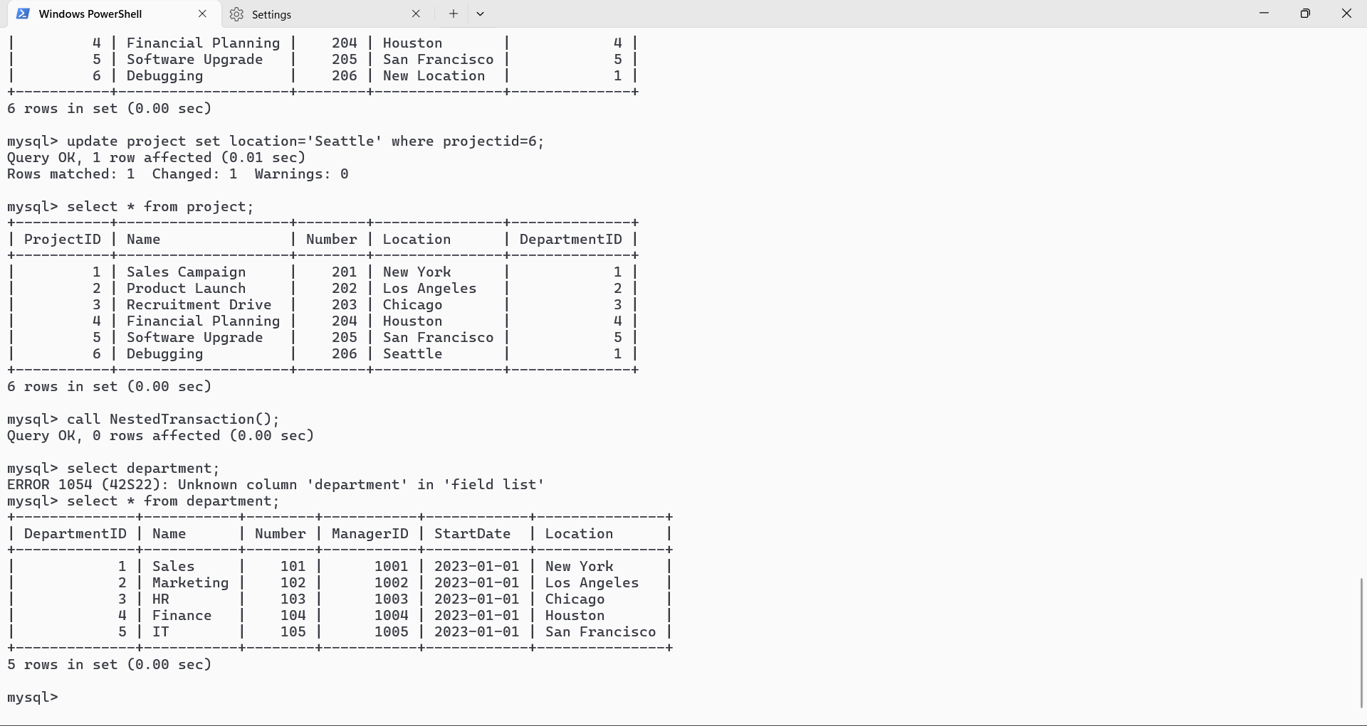

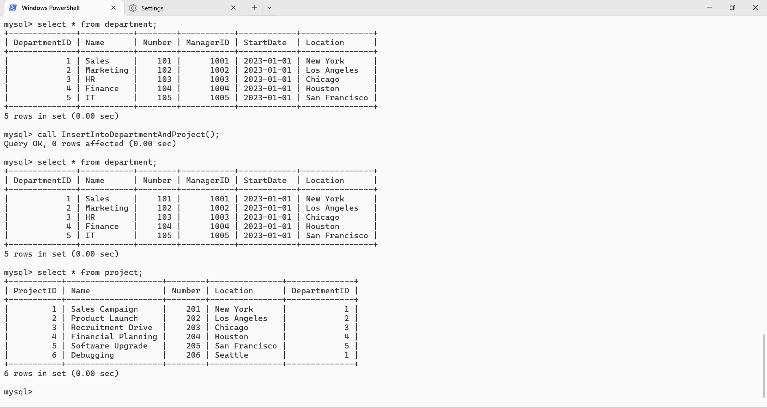

**Question 3: Start a transaction and within it, begin a nested transaction. Insert a new department and update the name of an existing department. Commit the nested transaction, and then either commit or rollback the outer transaction based on specific conditions**

DELIMITER //

CREATE PROCEDURE NestedTransaction()

BEGIN

DECLARE rollback_outer_transaction BOOLEAN DEFAULT FALSE;

START TRANSACTION

SAVEPOINT nested_transaction_start;

INSERT INTO Department (DepartmentID, Name, Number, ManagerID, StartDate, Location)

VALUES (6, 'Service', 106, 1001, '2024-01-01', 'NewYork');

UPDATE Department SET Name = 'New Sales' WHERE DepartmentID = 1;

ROLLBACK TO nested_transaction_start;

RELEASE SAVEPOINT nested_transaction_start;

SET rollback_outer_transaction = TRUE;

IF rollback_outer_transaction THEN

ROLLBACK;

ELSE

COMMIT;

END IF;

END//

DELIMITER ;

**Question 4: Start a transaction and insert new records into multiple tables. Intentionally introduce an error, and if the error occurs, rollback the entire transaction.**

DELIMITER //

CREATE PROCEDURE InsertIntoDepartmentAndProject()

BEGIN

DECLARE error_occurred BOOLEAN DEFAULT FALSE;

START TRANSACTION;

INSERT INTO Department (DepartmentID, Name, Number, ManagerID, StartDate, Location)

VALUES (6, 'Service', 106, 1001, '2024-01-01', 'NewYork');

BEGIN

DECLARE EXIT HANDLER FOR SQLEXCEPTION

BEGIN

SET error_occurred := TRUE;

END

INSERT INTO Project (ProjectID, Name, Number, Location, DepartmentID)

VALUES (6, 'New Project', 206, 'New Location', 10); -- DepartmentID 10 does not exist

END;

IF error_occurred THEN

ROLLBACK;

ELSE

COMMIT;

END IF;END//DELIMITER ;

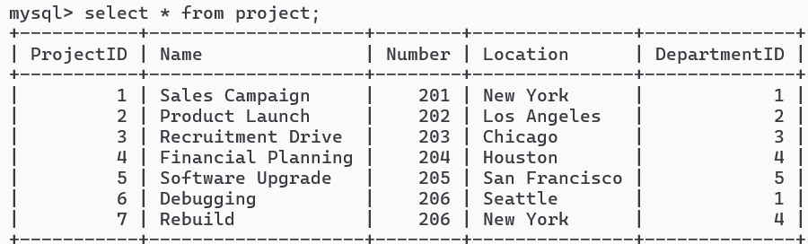

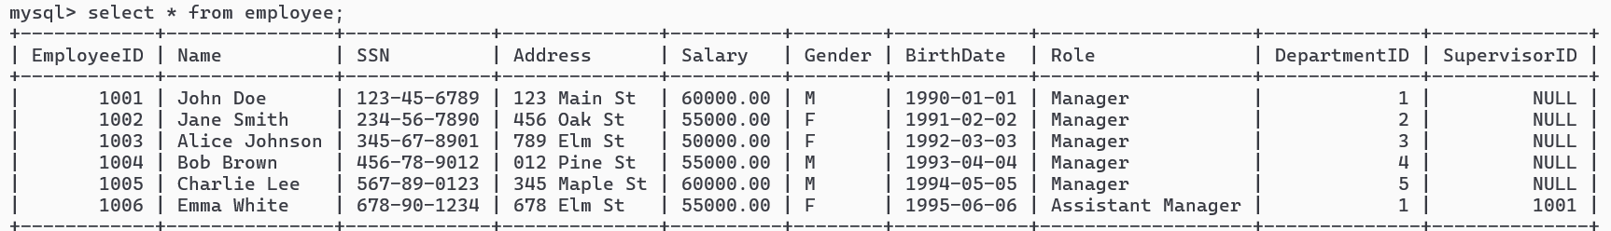

**QUESTION 5: Within a transaction, create multiple nested save points and perform operations. Rollback to a specific save point if an error occurs in the nested operations**

DELIMITER //

CREATE PROCEDURE NestedSavepointsWithMultipleOperations()

BEGIN

DECLARE error_occurred BOOLEAN DEFAULT FALSE;

START TRANSACTION;

INSERT INTO Project (ProjectID, Name, Number, Location, DepartmentID)

VALUES (7, 'Rebuild', 206, 'New York', 4);

SAVEPOINT savepoint_A;

BEGIN

DECLARE CONTINUE HANDLER FOR SQLEXCEPTION SET error_occurred := TRUE;

INSERT INTO NonExistingTable (NonExistingColumn) VALUES ('Value');

END;

IF error_occurred THEN

ROLLBACK TO savepoint_A;

ELSE

SAVEPOINT savepoint_B;

INSERT INTO Employee (EmployeeID, Name, SSN, Address, Salary, Gender, BirthDate, Role, DepartmentID, SupervisorID)

VALUES (1007, 'Rohan', '678-90-1234', '234 Den St', 60400.00, 'M', '1994-05-01', 'Employee', 2, NULL);

SAVEPOINT savepoint_C;

UPDATE Department SET Location = 'Updated Location' WHERE DepartmentID = 1

IF error_occurred THEN

ROLLBACK TO savepoint_B;

ELSE

COMMIT;

**RESULT**

**Studied and implemented queries using temp tables.**

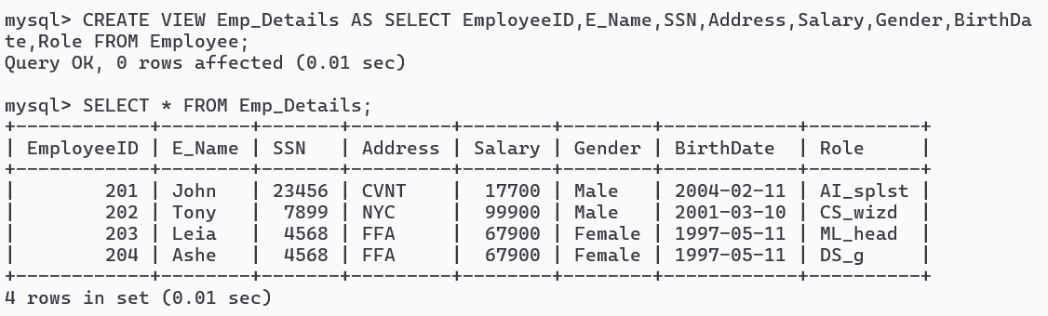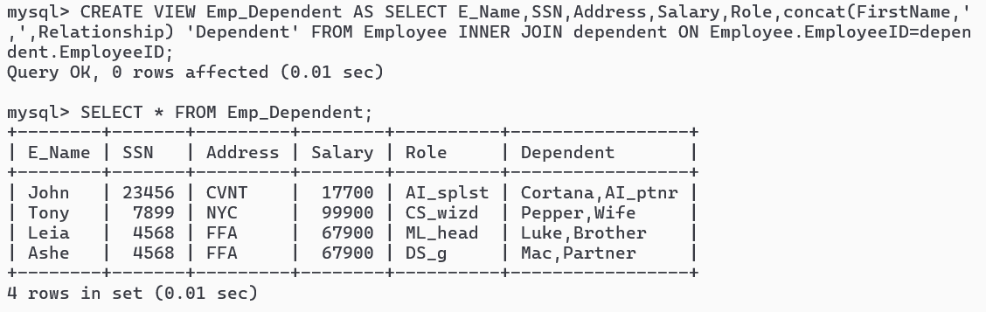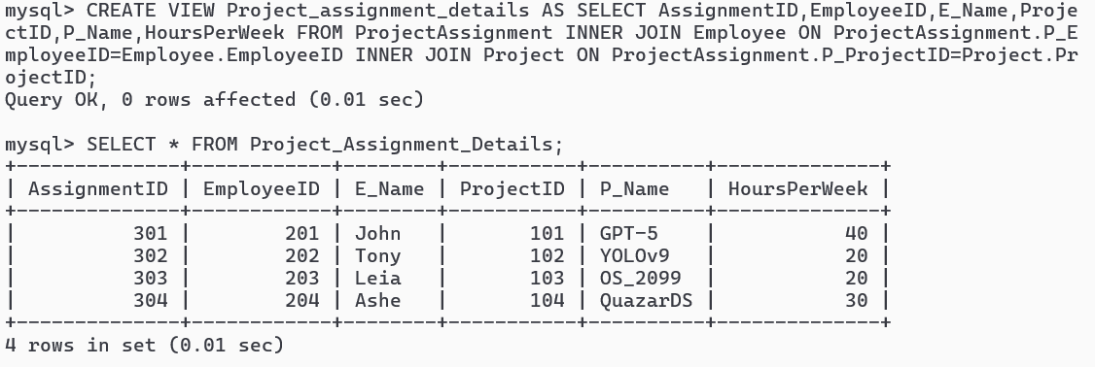

**EXP NO: 11**

**Practice of SQL commands for creation of views and assertions**

**AIM**

Practice of SQL commands for creation of views and assertions

**THEORY**

Views in SQL are kind of virtual tables. A view also has rows and columns as they are in a real table in the database. We can create a view by selecting fields from one or more tables present in the database. A View can either have all the rows of a table or specific rows based on certain condition.

CREATE VIEW *view_name* AS  
SELECT *column1*, *column2*,...  
FROM *table_name*  
WHERE *condition*;

**QUESTIONS**

* + - 1. **Create a view that includes essential details about each employee.**

CREATE VIEW Emp_Details AS SELECT EmployeeID,E_Name,SSN,Address,Salary,Gender,BirthDate,Role FROM Employee;

* + - 1. **Create a view that displays information about project assignments for employees**

CREATE VIEW Project_assignment_details AS SELECT AssignmentID,EmployeeID,E_Name,ProjectID,P_Name,HoursPerWeek FROM ProjectAssignment INNER JOIN Employee ON ProjectAssignment.P_EmployeeID=Employee.EmployeeID INNER JOIN Project ON ProjectAssignment.P_ProjectID=Project.ProjectID;

* + - 1. **Create a view showing employee details along with information about their dependents.**

CREATE VIEW Emp_Dependent AS SELECT E_Name,SSN,Address,Salary,Role,concat(FirstName,',',Relationship) 'Dependent' FROM Employee INNER JOIN dependent ON Employee.EmployeeID=dependent.EmployeeID;

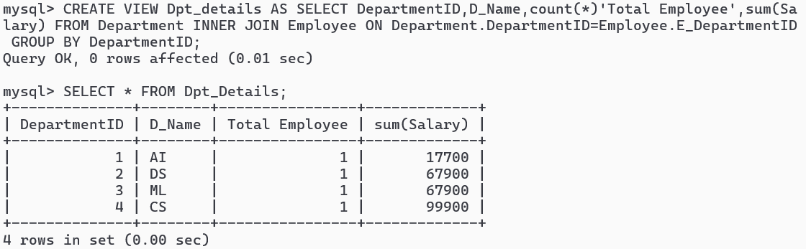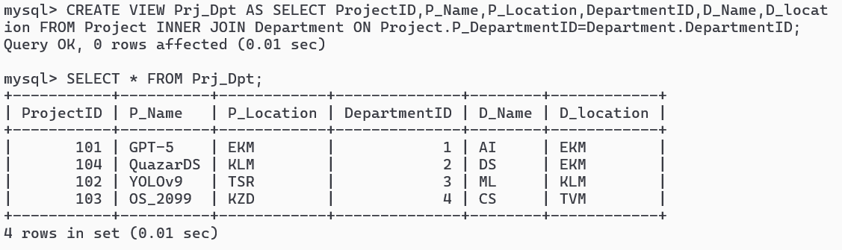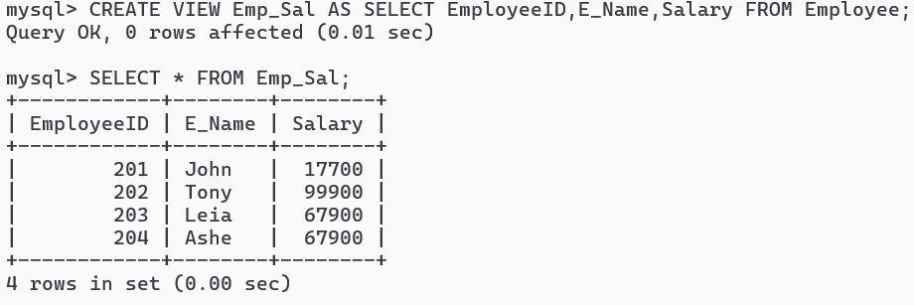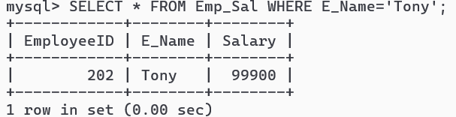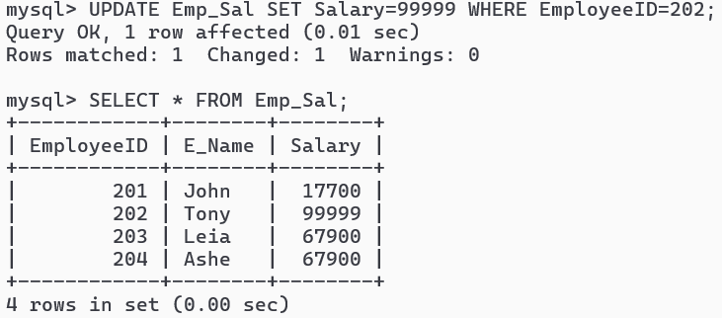

* + - 1. **Create a view that combines project details with the corresponding department information**

CREATE VIEW Prj_Dpt AS SELECT ProjectID,P_Name,P_Location,DepartmentID,D_Name,D_location FROM Project INNER JOIN Department ON Project.P_DepartmentID=Department.DepartmentID;

* + - 1. **Create a view that summarizes information about each department, including the total number of employees and total salary.**

CREATE VIEW Dpt_details AS SELECT DepartmentID,D_Name,count(*)'Total Employee',sum(Salary) FROM Department INNER JOIN Employee ON Department.DepartmentID=Employee.E_DepartmentID GROUP BY DepartmentID;

* + - 1. **Check data in view Emp-Sal**

CREATE VIEW Emp_Sal AS SELECT EmployeeID,E_Name,Salary FROM Employee;

SELECT * FROM Emp_Sal;

1. **Search view for a given employee**

SELECT * FROM Emp_Sal WHERE E_Name=’Tony’;

1. **UODATE Emp View**

UPDATE Emp_Sal SET Salary=99999 WHERE EmployeeID=202;

**9. Check the updated data in view**

SELECT * FROM Emp_Sal;

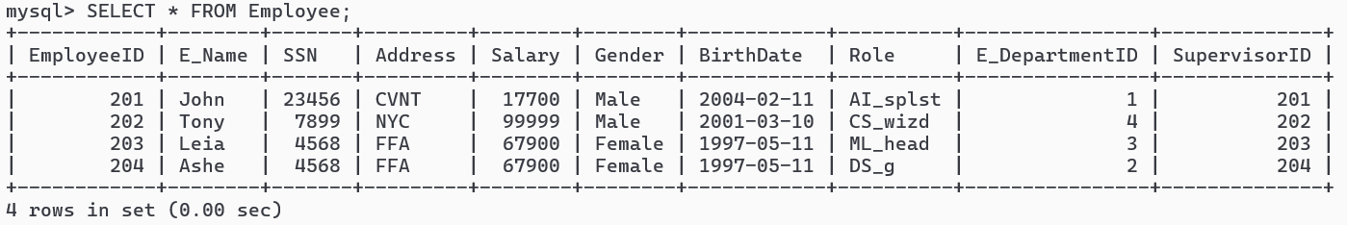

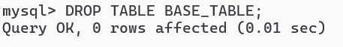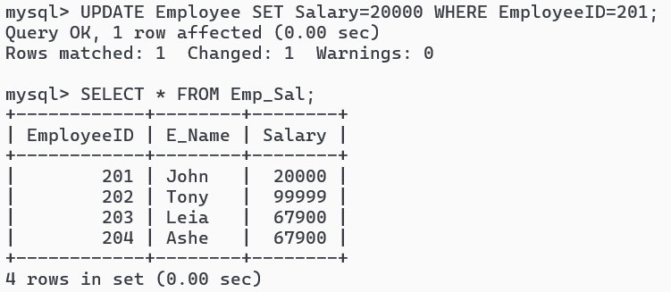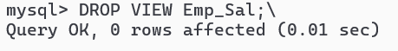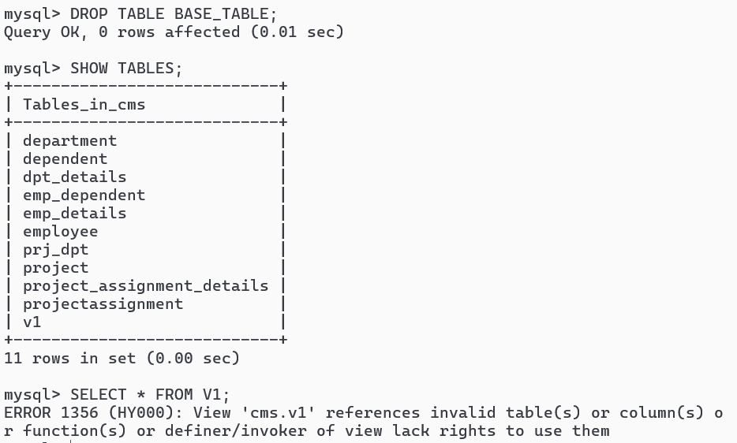

**10. Check if the source table is updated or not**

SELECT * FROM Employee;

**11. Update Base table, and check if View is updated or not**

UPDATE Employee SET Salary=20000 WHERE EmployeeID=201;

**12. Check if View got changes**

SELECT * FROM Emp_Sal;

**13. Delete View**

DROP VIEW Emp_Sal;

**14. Drop Base Table**

DROP TABLE BASE_TABLE ;

**15. Verify deletion of base table will automatically delete view**

SHOW TABLES;

SELECT * FROM V1;

**RESULT**

Successfully Performed and Executed SQL commands for creation of views and assertions

CYCLE 2 – PL/SQL

**Exp No:12**

**PL/SQL Introduction.**

**AIM:** To implement various various control structures like IF-THEN,IF-THEN-ELSE,IF-THEN ELSIF,CASE ,WHILE USING PL/SQL

Procedural Language/Structured Query Language (PL/SQL) is an extension of SQL

Basic Syntax of PL/SQL

*DECLARE*

*/* Variables can be declared here */*

*BEGIN*

*/* Executable statements can be written here */*

*EXCEPTION*

*/* Error handlers can be written here. */*

*END;*

As we want output of PL/SQL Program on screen, before Starting writing anything type (Only

Once per session)

SET SERVEROUTPUT ON

**Sample 1: Hello World Program**

*DECLARE*

*age integer;*

*name VARCHAR(20);*

*BEGIN*

*dbms_output.put_line('Hello world');*

*--dbms_output.put_line('age = ' || age);*

*--dbms_output.put_line('name = ' || name);*

*--insert into Stud values(&rollno, '&name', &mark1, &mark2, &mark3);*

*END;*

*/*

**Sampe 2**: **Find the largest of two integers.**

(Use of “If else” in PL/SQL)

*DECLARE*

*a integer := &a;*

*b integer := &b;*

*BEGIN*

*if (a > b) then*

*dbms_output.put_line(a || ' is the largest number');*

*else*

*dbms_output.put_line(b || ' is the largest number');*

*end if;*

*END;*

**Sample 3**: **Print the range of two integers.**

**(Use of if elsif ladder)**

*DECLARE*

*c integer := &c;*

*BEGIN*

*if (c >= 0 and c < 10) then*

*dbms_output.put_line(' is less than 10');*

*elsif (c >= 10 and c < 20) then*

*dbms_output.put_line(' is less than 20');*

*elsif (c >= 20 and c < 30) then*

*dbms_output.put_line(' is less than 30');*

*else*

*dbms_output.put_line(' is grater than or equal 30');*

*end if;*

*END;*

***Sample 4****:* ***Print the performance rating.***

***(Use of case statement)***

*DECLARE*

*c char(1) := '&c';*

*BEGIN*

*case c*

*when 'A' then dbms_output.put_line('Excellent');*

*when 'B' then dbms_output.put_line('Very good');*

*when 'C' then dbms_output.put_line('Well done');*

*when 'D' then dbms_output.put_line('You passed');*

*when 'F' then dbms_output.put_line('Better try again');*

*else dbms_output.put_line('No such grade');*

*end case;*

*END;*

***Sample 5: Use of Array and Loops in PL/SQL***

***Please note:***

***- Default index starts from 1***

***- D*eclared using the TYPE keyword**

*DECLARE*

*type intArray IS VARRAY(10) OF INTEGER;*

*type namesArray IS VARRAY(5) OF VARCHAR2(5);*

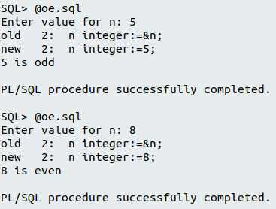

*arr intArray;*

*names namesArray;*

*i integer;*

*BEGIN*

*arr := intArray(1,5,2,3,6,7,4,8,9,10);*

*names := namesArray('Alice', 'Bob', 'Cindy', 'Sam', 'Eric');*

*i := 1;*

*/*While loop...! */*

*while( i <= 10) loop*

*dbms_output.put_line('arr[' || i ||'] =' ||arr(i));*

*i := i+1;*

*end loop;*

*/*For loop...! */*

*for i in 1 .. 10 loop*

*dbms_output.put_line('arr[' || i ||'] =' ||arr(i));*

*end loop;*

*/* while loop */*

*i := 1;*

*while( i <= 5) loop*

*dbms_output.put_line('names[' || i ||'] =' ||names(i));*

*i := i+1;*

*end loop;*

*/*For loop...! */*

*for i in 1 .. 5 loop*

*dbms_output.put_line('names[' || i ||'] =' ||names(i));*

*end loop;*

*END;*

***Question 1: Write a plsql program to check whether a given number is ODD or EVEN***

*DECLARE*

*number integer;*

*BEGIN*

*-- get role no from user*

*number := &number;*

*--calculate & print result*

*if (mod(number,2) = 0) then*

*dbms_output.put_line('EVEN Number');*

*else*

*dbms_output.put_line('ODD Number');*

*end if;*

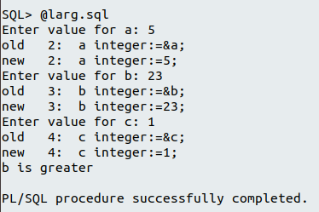

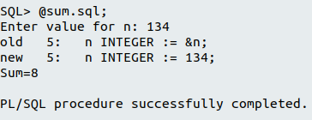

*END;*

*/*

***Question 2: Write a PL/SQL block to find the maximum number from given three numbers.***

*DECLARE*

*number1 integer := &number1;*

*number2 integer := &number2;*

*number3 integer := &number3;*

*BEGIN*

*--calculate & print result*

*if (number1 > number2 and number1>number3) then*

*dbms_output.put_line('Greatest is ' || number1);*

*elsif (number2 > number2 and number2>number3) then*

*dbms_output.put_line('Greatest is ' || number2);*

*else*

*dbms_output.put_line('Greatest is ' || number3);*

*end if;*

*END;*

*/*

***Question 3: Write a program to accept a number and find the sum of the digits***

*DECLARE*

*num integer :=&num;*

*total integer:=0;*

*digit integer:=0;*

*BEGIN*

*while (num !=0) loop*

*digit := mod(num,10);*

*total := total + digit;*

*num := trunc(num/10);*

*end loop;*

*dbms_output.put_line('sum of digits of given number is '||total);*

*END;*

*/*

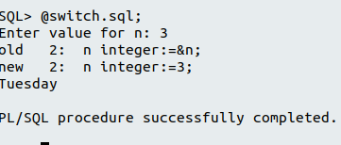

***Question 5: Program to print the days names in the week.***

*DECLARE*

*d number:=&num1;*

*BEGIN*

*case d*

*when 1 then*

*dbms_output.put_line('sunday');*

*when 2 then*

*dbms_output.put_line('monday');*

*when 3 then*

*dbms_output.put_line('tuesday');*

*when 4 then*

*dbms_output.put_line('wednesday');*

*when 5 then*

*dbms_output.put_line('thursday');*

*when 6 then*

*dbms_output.put_line('friday');*

*when 7 then*

*dbms_output.put_line('saturday');*

*else*

*dbms_output.put_line('invalid day');*

*end case;*

*END;*

*/*

***RESULT***

Studied and implemented various various control structures like IF-THEN,IF-THEN-ELSE,IF-THEN ELSIF,CASE ,WHILE USING PL/SQL.

**Exp No-13**

***Creation of Procedures and Triggers***

Creation of Triggers, Procedures and Functions

**AIM:** Design and implement Procedure and Triggers

**I. PROCEDURE**

In PL/SQL, a procedure is a named block of code that can be stored and executed in an Oracle database. It is a subroutine that performs a specific task or a series of tasks.

**Features**

1. Procedure Syntax

2. No return value

3. Parameters

a. **Procedure Syntax**

1. **Create a procedure**

CREATE [OR REPLACE] PROCEDURE procedure_name [ (parameter [,parameter]) ]

IS

[declaration_section]

BEGIN

executable_section

[EXCEPTION

exception_section]

END [procedure_name];

2. **Delete a procedure**

DROP PROCEDURE procedure_name;

**b. Parameters**

There are three types of parameters that can be declared:

1. IN - The parameter can be referenced by the procedure or function.

The value of the parameter can not be overwritten by the procedure or function.

2. OUT - The parameter can not be referenced by the procedure or function,

but the value of the parameter can be overwritten by the procedure or function.

3. IN OUT - The parameter can be referenced by the procedure or function and the

value of the parameter can be overwritten by the procedure or function.

**c. How differ from functions**

functions in PL/SQL are similar to procedures, but they return a value to the calling program.

Functions are defined using the CREATE FUNCTION statement

**d. How to use**

a. Compile the procedure from a .sql script

b. Write a pl/sql program in another script and call procedure from it.

**Question 1: Write a PL/SQL Procedure to find largest of two Numbers**

*CREATE OR REPLACE PROCEDURE FindLargest (*

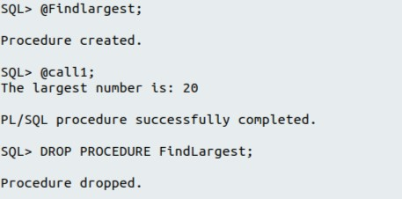

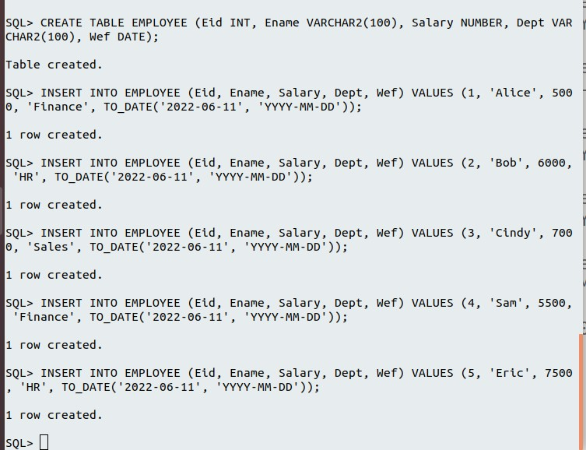

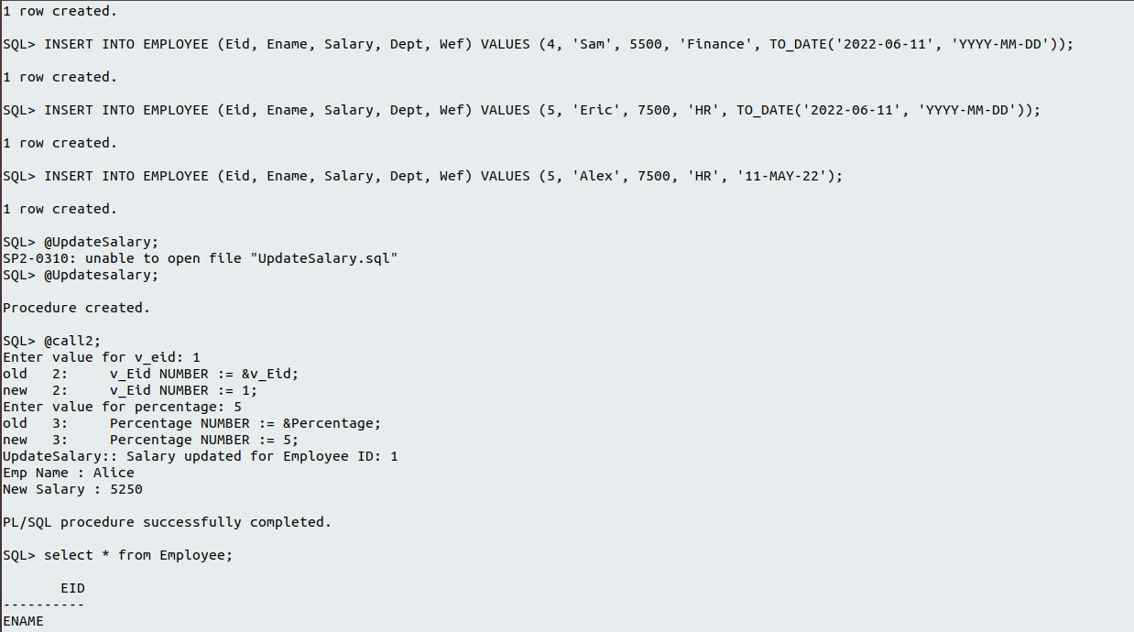

*num1 in integer,*

*num2 in integer,*

*largest out integer*

*) AS*

*BEGIN*

*IF num1 > num2 THEN*

*largest := num1;*

*ELSE*

*largest := num2;*

*END IF;*

*END;*

*/*

**-- How to use this procedure from a pl/sql program**

*DECLARE*

*num1 integer := 10;*

*num2 integer := 20;*

*result integer;*

*BEGIN*

*-- invoke procedure, just like function call*

*FindLargest(num1, num2, result);*

*dbms_output.put_line('The largest number is: ' || result);*

*END;*

*/*

**-- Delete Procedure**

*DROP PROCEDURE FindLargest;*

*/*

**Question 2: Create a table EMPLOYEE(Eid,Ename,salary,Dept,Wef). Write a procedure to accept two arguments Eid and Salary increment(in %). update the EMPLOYEE table with the salary increment also record the effective date.**

***-- create table***

*CREATE TABLE EMPLOYEE (Eid INT, Ename VARCHAR2(100), Salary NUMBER, Dept VARCHAR2(100), Wef DATE);*

***-- insert few data***

*INSERT INTO EMPLOYEE (Eid, Ename, Salary, Dept, Wef)*

*VALUES (1, 'Alice', 5000, 'Finance', TO_DATE('2022-06-11', 'YYYY-MM-DD'));*

*INSERT INTO EMPLOYEE (Eid, Ename, Salary, Dept, Wef)*

*VALUES (2, 'Bob', 6000, 'HR', TO_DATE('2022-06-11', 'YYYY-MM-DD'));*

*INSERT INTO EMPLOYEE (Eid, Ename, Salary, Dept, Wef)*

*VALUES (3, 'Cindy', 7000, 'Sales', TO_DATE('2022-06-11', 'YYYY-MM-DD'));*

*INSERT INTO EMPLOYEE (Eid, Ename, Salary, Dept, Wef)*

*VALUES (4, 'Sam', 5500, 'Finance', TO_DATE('2022-06-11', 'YYYY-MM-DD'));*

*INSERT INTO EMPLOYEE (Eid, Ename, Salary, Dept, Wef)*

*VALUES (5, 'Eric', 7500, 'HR', TO_DATE('2022-06-11', 'YYYY-MM-DD'));*

***-- default name format 'DD-MON-YY' which is different from mysql***

*INSERT INTO EMPLOYEE (Eid, Ename, Salary, Dept, Wef)*

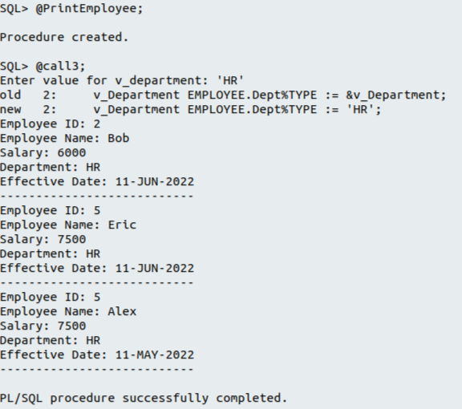

*VALUES (5, 'Alex', 7500, 'HR', '11-MAY-22');*

***-- Procedure definition***

*CREATE OR REPLACE PROCEDURE UpdateSalary(*

*v_Eid IN EMPLOYEE.Eid%TYPE,*

*v_Increment IN NUMBER*

*) AS*

*BEGIN*

*UPDATE EMPLOYEE*

*SET Salary = Salary + (Salary * v_Increment / 100), Wef = SYSDATE*

*WHERE Eid = v_Eid;*

*dbms_output.put_line('UpdateSalary:: Salary updated for Employee ID: ' || v_Eid);*

*END;*

***-- How to use this procedure from a pl/sql program***

*DECLARE*

*v_Eid NUMBER := &v_Eid;*

*Percentage NUMBER := &Percentage;*

*v_Salary EMPLOYEE.Salary % TYPE;*

*v_Ename EMPLOYEE.Ename % TYPE;*

*BEGIN*

*UpdateSalary(v_Eid, Percentage);*

*select Salary, Ename into v_Salary, v_Ename from EMPLOYEE where Eid = v_Eid;*

*dbms_output.put_line('Emp Name : ' || v_Ename);*

*dbms_output.put_line('New Salary : ' || v_Salary);*

*END;*

*/*

**Question 3: Print all employees in a given department.**

*CREATE OR REPLACE PROCEDURE PrintEmployeesByDepartment(*

*v_Department IN EMPLOYEE.Dept%TYPE*

*) AS*

*BEGIN*

*FOR emp IN (select * from EMPLOYEE where Dept = v_Department) LOOP*

*dbms_output.put_line('Employee ID: ' || emp.Eid);*

*dbms_output.put_line('Employee Name: ' || emp.Ename);*

*dbms_output.put_line('Salary: ' || emp.Salary);*

*dbms_output.put_line('Department: ' || emp.Dept);*

*dbms_output.put_line('Effective Date: ' || TO_CHAR(emp.Wef, 'DD-MON-YYYY'));*

*dbms_output.put_line('---------------------------');*

*END LOOP;*

*END;*

*/*

**-- How to use this procedure from a pl/sql program**

*DECLARE*

*v_Department EMPLOYEE.Dept%TYPE := &v_Department;*

*BEGIN*

*PrintEmployeesByDepartment(v_Department);*

*END;*

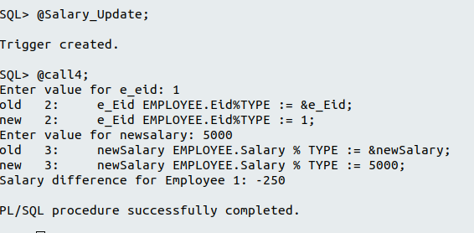

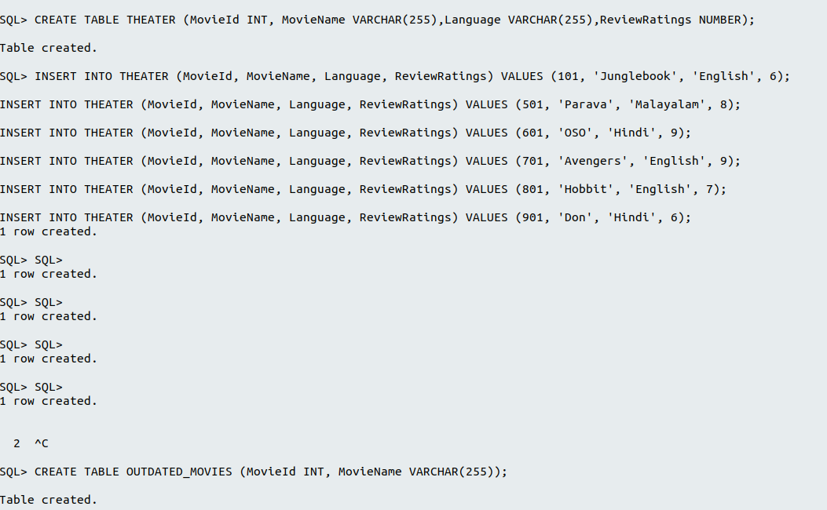

**II. TRIGGER**

A trigger is a procedure that is automatically invoked by the DBMS in response to specified changes to the database, and is typically specified by the DBA.. A database that has a set of associated triggers is called an Active Database.

A trigger description contains three parts:

**Event** : A change to the database that activates the trigger.

**Condition** : A query or test that is run when the trigger is activated.

**Action** : A procedure that is executed when the trigger is activated and its condition is

true.

An insert, delete, or update statement could activate a trigger, regardless of which user or application invoked the activating statement; users may not even be aware that a trigger was executed as a side effect of their program.

**Question 1. create a trigger which shows the salary difference of a particular employee whenever salary is getting updated**

***-- trigger definition***

*CREATE OR REPLACE TRIGGER Salary_Update_Trigger*

*BEFORE UPDATE OF Salary ON EMPLOYEE*

*FOR EACH ROW*

*DECLARE*

*old_salary NUMBER;*

*new_salary NUMBER;*

*BEGIN*

*IF :OLD.Eid = :NEW.Eid THEN*

*old_salary := :OLD.Salary;*

*new_salary := :NEW.Salary;*

*DBMS_OUTPUT.PUT_LINE('Salary difference for Employee ' || :NEW.Eid || ': ' || (new_salary - old_salary));*

*END IF;*

*END;*

*/*

***-- How to test***

*-- Reuse the EMPLOYEE data in last program,*

*-- If data set is empty, insert data as in last program*

*-- Execute below pl.sql program, that update employee salary*

*DECLARE*

*e_Eid EMPLOYEE.Eid%TYPE := &e_Eid;*

*newSalary EMPLOYEE.Salary % TYPE := &newSalary;*

*BEGIN*

*update EMPLOYEE SET Salary = newSalary WHERE Eid = e_Eid;*

*END;*

***Question 2: Create a table THEATER(MovieId, movieName, Language, ReviewRatings). Whenever rating goes below 5 , the movies has to be removed from THEATER table and***

***add to table OUTDATED_MOVIES with attributes MovieId and MovieName. Write a trigger for above problem***

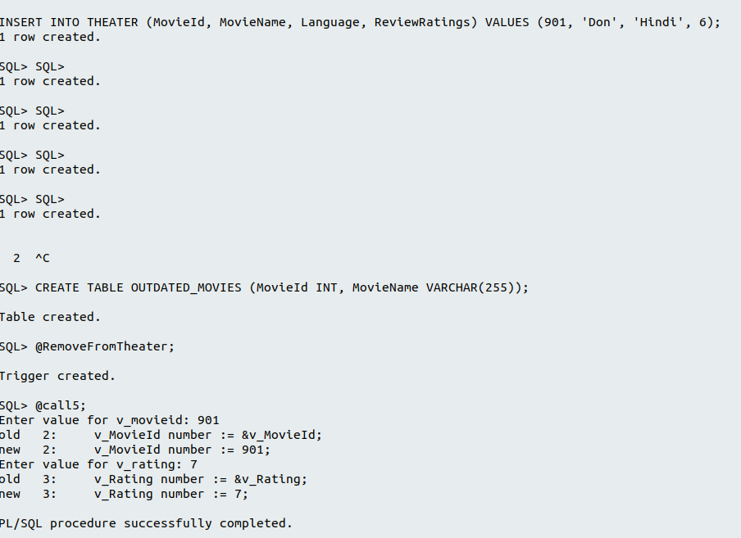

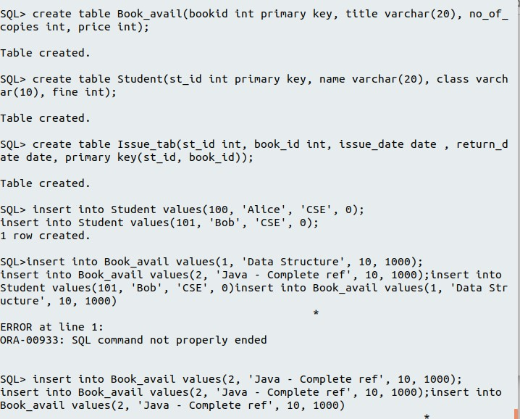

***-- create table***

*CREATE TABLE THEATER (MovieId INT, MovieName VARCHAR(255), Language VARCHAR(255),*

*ReviewRatings NUMBER);*

***-- Insert values into THEATER table***

*INSERT INTO THEATER (MovieId, MovieName, Language, ReviewRatings)*

*VALUES (101, 'Junglebook', 'English', 6);*

*INSERT INTO THEATER (MovieId, MovieName, Language, ReviewRatings)*

*VALUES (501, 'Parava', 'Malayalam', 8);*

*INSERT INTO THEATER (MovieId, MovieName, Language, ReviewRatings)*

*VALUES (601, 'OSO', 'Hindi', 9);*

*INSERT INTO THEATER (MovieId, MovieName, Language, ReviewRatings)*

*VALUES (701, 'Avengers', 'English', 9);*

*INSERT INTO THEATER (MovieId, MovieName, Language, ReviewRatings)*

*VALUES (801, 'Hobbit', 'English', 7);*

*INSERT INTO THEATER (MovieId, MovieName, Language, ReviewRatings)*

*VALUES (901, 'Don', 'Hindi', 6);*

*CREATE TABLE OUTDATED_MOVIES (MovieId INT, MovieName VARCHAR(255));*

***/* Triger */***

*CREATE OR REPLACE TRIGGER Remove_From_Theater*

*AFTER DELETE ON THEATER*

*FOR EACH ROW*

*BEGIN*

*DBMS_OUTPUT.PUT_LINE('Movie id : ' || :OLD.MovieId);*

*DBMS_OUTPUT.PUT_LINE('MovieName : ' || :OLD.MovieName);*

*insert into OUTDATED_MOVIES values (:OLD.MovieId, :OLD.MovieName);*

*END;*

***-- How to use this trigger***

*DECLARE*

*v_MovieId number := &v_MovieId;*

*v_Rating number := &v_Rating;*

*BEGIN*

*if (v_Rating < 5) then*

*delete from THEATER where MovieId = v_MovieId;*

*end if;*

*END;*

*/*

***Question 3***

***Create a database trigger to calculate the fine based on the rules given below.***

***After 1 month 5% of price***

***After 2 month 10% of price***

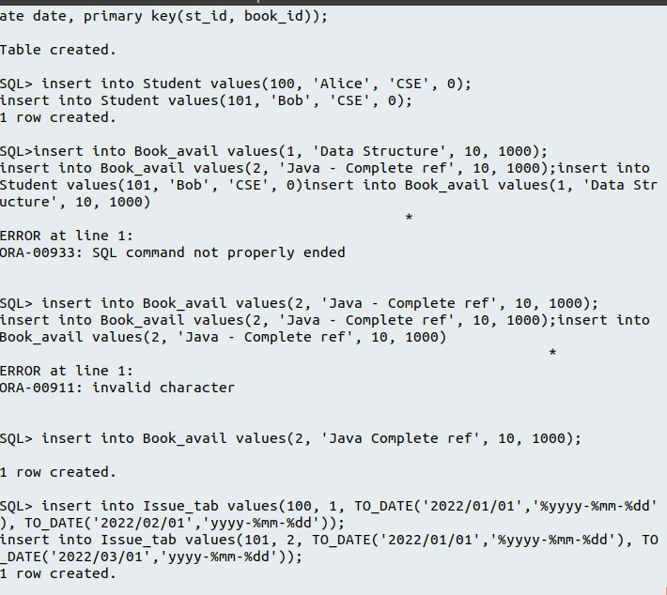

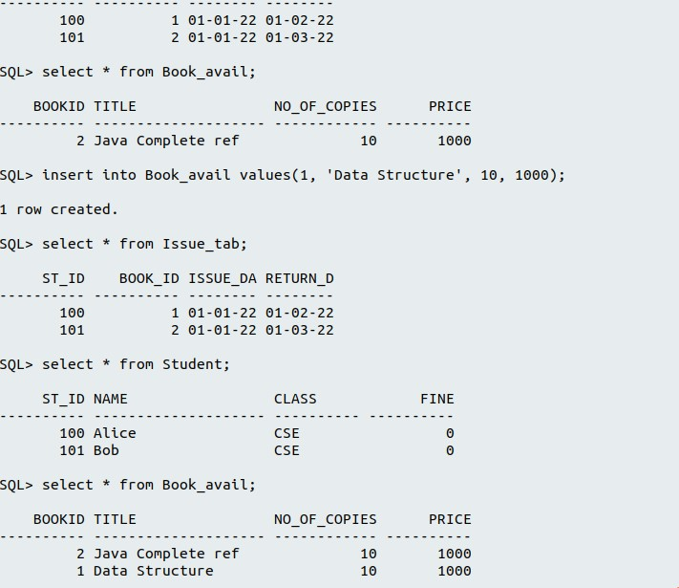

***After 3 month 20% of price.***

***Schema:***

***Book_avail (bookid, title, no_of _copies, price)***

***Student (st_id,name,class,fine)***

***Issue_tab (st_id, book_id, issuedate, returndate)***

***-- create table***

*create table Book_avail(bookid int primary key, title varchar(20), no_of_copies int, price int);*

*create table Student(st_id int primary key, name varchar(20), class varchar(10), fine int);*

*create table Issue_tab(st_id int, book_id int, issue_date date , return_date date, primary key(st_id, book_id));*

***-- insert few data***

*insert into Student values(100, 'Alice', 'CSE', 0);*

*insert into Student values(101, 'Bob', 'CSE', 0);*

*insert into Book_avail values(1, 'Data Structure', 10, 1000);*

*insert into Book_avail values(2, 'Java - Complete ref', 10, 1000);*

*insert into Issue_tab values(100, 1, TO_DATE('2022/01/01','%yyyy-%mm-%dd'), TO_DATE('2022/02/01','yyyy-%mm-%dd'));*

*insert into Issue_tab values(101, 2, TO_DATE('2022/01/01','%yyyy-%mm-%dd'), TO_DATE('2022/03/01','yyyy-%mm-%dd'));*

*select * from Issue_tab;*

*select * from Student;*

*select * from Book_avail;*

*/* trigger */*

*CREATE OR REPLACE TRIGGER Calc_Late_Fine*

*AFTER UPDATE ON Issue_tab*

*REFERENCING NEW AS NEW OLD AS OLD*

*FOR EACH ROW*

*DECLARE*

*v_bprice int;*

*v_months int;*

*v_latefine int;*

*v_bookid int;*

*BEGIN*

*v_bookid := :OLD.book_id;*

*-- get book price from book table*

*select price into v_bprice from Book_avail where bookid = v_bookid;*

*dbms_output.put_line('v_bookid = ' || v_bookid);*

*dbms_output.put_line('v_bprice = ' || v_bprice);*

*-- get months after student returning book*

*v_months:=months_between(:new.return_date,:old.issue_date);*

*dbms_output.put_line('v_months = ' || v_months);*

*-- Calculate fine while update issue_tab*

*if v_months>=1 and v_months<2 then*

*v_latefine := v_bprice*0.05;*

*else if v_months>=2 and v_months<3 then*

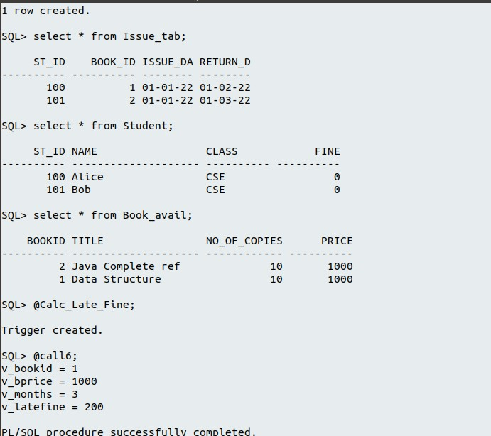

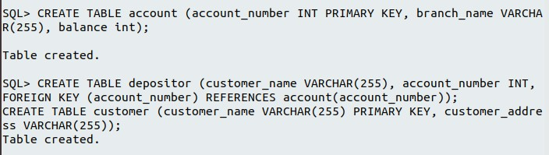

*v_latefine := v_bprice*0.01;*

*else if v_months>=3 then*

*v_latefine := v_bprice*0.2;*

*end if;*

*end if;*

*end if;*

*-- Update fine into Student table while update issue_tab*

*dbms_output.put_line('v_latefine = ' || v_latefine);*

*update Student set fine=v_latefine where st_id=:old.st_id;*

*END;*

*/*

***-- How to test this trigger***

*update Issue_tab set return_date=TO_DATE('2022/04/02','%yyyy-%mm-%dd') where st_id=100;*

***Question 4***

***consider the bank databse***

***account (account_number, branch_name , balance);***

***depositor (customer_name, account_number);***

***customer (customer_name, customer_address);***

***Write SQL Trigger to carryput following action***

***On delete of an account, for each customer-owner of the account, check if the owner has any remaining account, and if she/he does not, delete her/him from depositor relation.***

***-- create tables & populate table***

*CREATE TABLE account (account_number INT PRIMARY KEY, branch_name VARCHAR(255), balance int);*

*CREATE TABLE depositor (customer_name VARCHAR(255), account_number INT, FOREIGN KEY (account_number) REFERENCES account(account_number));*

*CREATE TABLE customer (customer_name VARCHAR(255) PRIMARY KEY, customer_address VARCHAR(255));*

*insert into account values(1,'TVM',100000);*

*insert into account values(2,'TVM',200000);*

*insert into account values(3,'TVM',300000);*

*insert into account values(4,'TVM',400000);*

*insert into account values(5,'Cochin',500000);*

*insert into customer values('Alice', 'Address1');*

*insert into customer values('Bob', 'Address2');*

*insert into customer values('Cindy', 'Address3');*

*insert into depositor values('Alice', 1);*

*insert into depositor values('Alice', 2);*

*insert into depositor values('Alice', 3);*

*insert into depositor values('Bob', 4);*

*insert into depositor values('Cindy', 5);*

*DELIMITER //*

*CREATE TRIGGER Trigger1234*

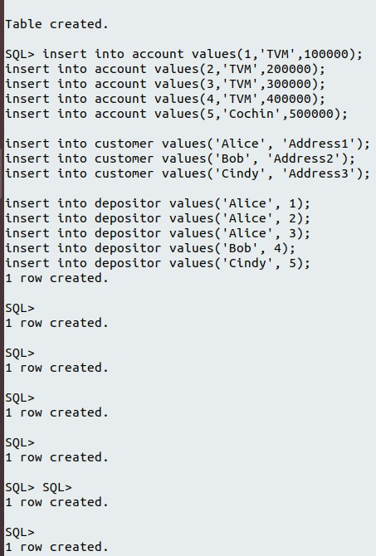

*AFTER DELETE ON account*

*FOR EACH ROW*

*BEGIN*

*declare*

*c_name varchar(30);*

*select customer_name into c_name from depositor where account_number = old.account_number;*

*if (select count(*) from depositor d where d.customer_name = c_name ) > 1 then*

*signal sqlstate '45000' set message_text = 'Error..! Delete Not Allowed in depositor table: Customer has more accounts ';*

*else*

*DELETE FROM depositor WHERE account_number = old.account_number;*

*end if;*

*END*

*//*

*DELIMITER ;*

***-- Testing trigger***

*DELETE FROM account WHERE account_number = 2;*

***-- output***

*mysql> DELETE FROM account WHERE account_number = 2;*

*ERROR 1644 (45000): Error..! Delete Not Allowed in depositor table: Customer has more accounts*

**RESULT**

Studied and implemented Procedure and Triggers.

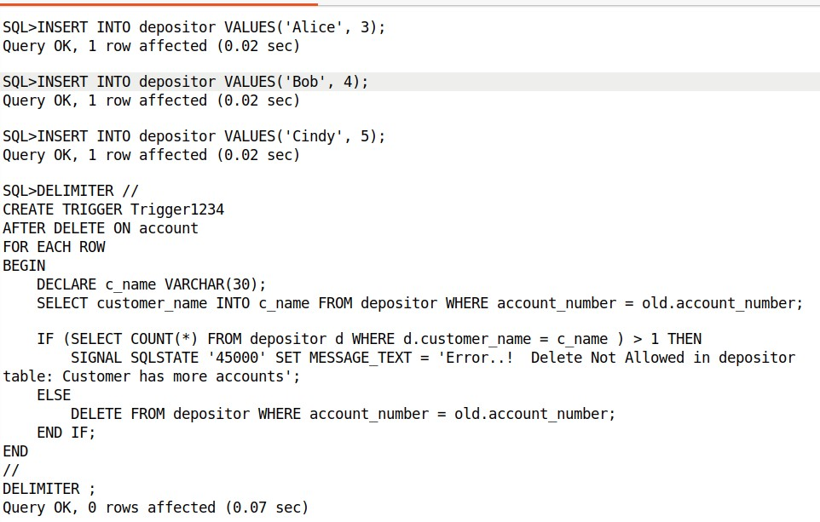

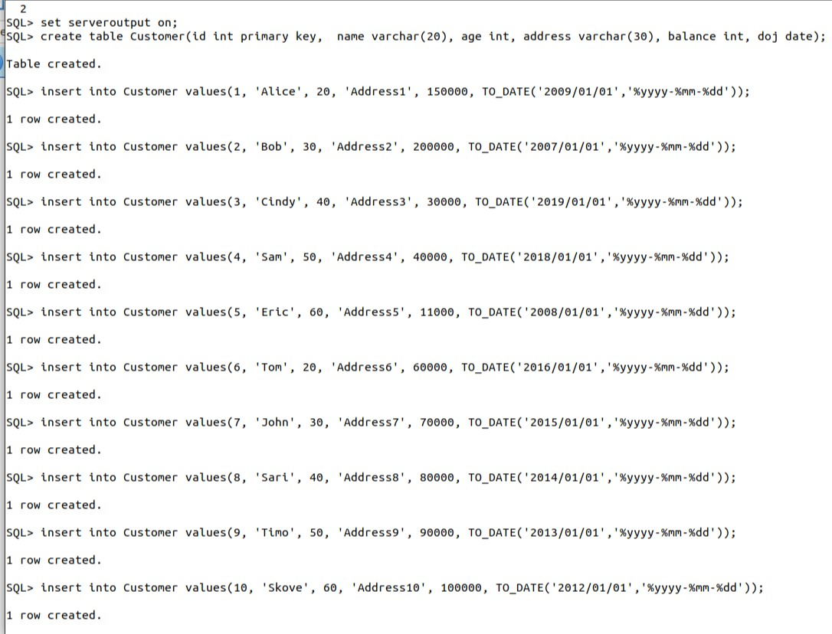

**Exp No-14**

***Creation of Cursor***

**AIM** Create a PL/SQL Cursors

**Cursors**

A cursor is a named control structure used by an application program to point to and select a row of data from a result set. Instead of executing a query all at once, you can use a cursor to read and process the query result set one row at a time.

**Implicit Cursors:**

An implicit cursor is a session cursor that is constructed and managed by PL/SQL. PL/SQL opens an implicit cursor every time you run a SELECT or DML statement. You cannot control an implicit cursor, but you can get information from its attributes.

**Explicit Cursors:**

Explicit Cursors are Created by Users whenever the user requires them. Explicit Cursors are used for Fetching data from Table in Row-By-Row Manner.

**How to create Explicit Cursor:**

Declare Cursor Object.

Syntax : DECLARE cursor_name CURSOR FOR SELECT * FROM table_name

DECLARE s1 CURSOR FOR SELECT * FROM studDetails

**Open Cursor Connection.**

Syntax : OPEN cursor_connection

OPEN s1

**Fetch Data from cursor.**

There are total 6 methods to access data from cursor. They are as follows :

FIRST is used to fetch only the first row from cursor table.

LAST is used to fetch only last row from cursor table.

NEXT is used to fetch data in forward direction from cursor table.

PRIOR is used to fetch data in backward direction from cursor table.ABSOLUTE n is used to fetch the exact nth row from cursor table.

RELATIVE n is used to fetch the data in incremental way as well as decremental way.

Syntax : FETCH NEXT/FIRST/LAST/PRIOR/ABSOLUTE n/RELATIVE n FROM cursor_name

FETCH FIRST FROM s1

FETCH LAST FROM s1

FETCH NEXT FROM s1

FETCH PRIOR FROM s1

FETCH ABSOLUTE 7 FROM s1

FETCH RELATIVE -2 FROM s1

**Close cursor connection.**

Syntax : CLOSE cursor_name

CLOSE s1

**Deallocate cursor memory.**

Syntax : DEALLOCATE cursor_name

DEALLOCATE s1

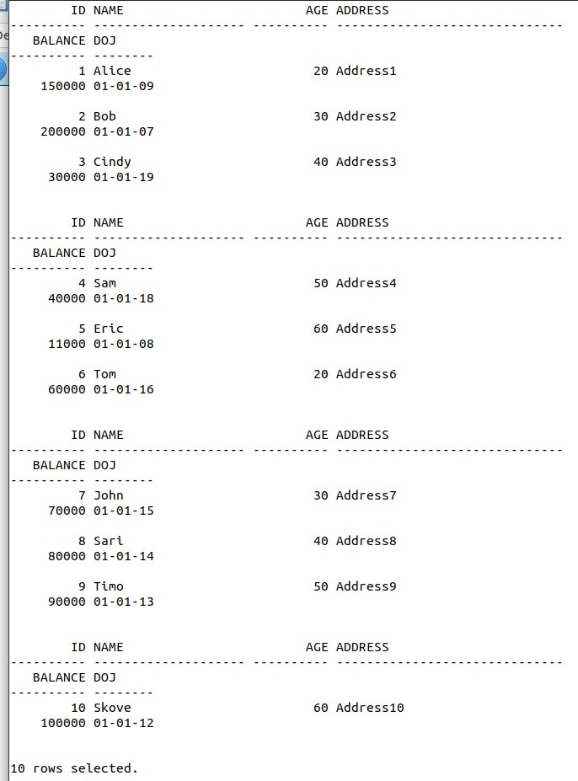

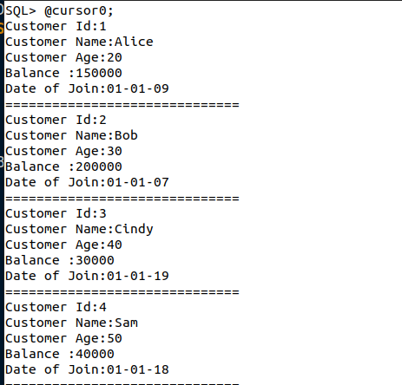

**Question 1: Consider the table**

**Customer (accout no, customer name,balance amount,date of join).**

**Write a pl/sql program using cursor to display the id, name, age, Balance, and date of join of all employees in Customer table.**

*set serveroutput on;*

*create table Customer(id int primary key, name varchar(20), age int, address varchar(30), balance int, doj date);*

*insert into Customer values(1, 'Alice', 20, 'Address1', 150000, TO_DATE('2009/01/01','%yyyy-%mm-%dd'));*

*insert into Customer values(2, 'Bob', 30, 'Address2', 200000, TO_DATE('2007/01/01','%yyyy-%mm-%dd'));*

*insert into Customer values(3, 'Cindy', 40, 'Address3', 30000, TO_DATE('2019/01/01','%yyyy-%mm-%dd'));*

*insert into Customer values(4, 'Sam', 50, 'Address4', 40000, TO_DATE('2018/01/01','%yyyy-%mm-%dd'));*

*insert into Customer values(5, 'Eric', 60, 'Address5', 11000, TO_DATE('2008/01/01','%yyyy-%mm-%dd'));*

*insert into Customer values(6, 'Tom', 20, 'Address6', 60000, TO_DATE('2016/01/01','%yyyy-%mm-%dd'));*

*insert into Customer values(7, 'John', 30, 'Address7', 70000, TO_DATE('2015/01/01','%yyyy-%mm-%dd'));*

*insert into Customer values(8, 'Sari', 40, 'Address8', 80000, TO_DATE('2014/01/01','%yyyy-%mm-%dd'));*

*insert into Customer values(9, 'Timo', 50, 'Address9', 90000, TO_DATE('2013/01/01','%yyyy-%mm-%dd'));*

*insert into Customer values(10, 'Skove', 60, 'Address10', 100000, TO_DATE('2012/01/01','%yyyy-%mm-%dd'));*

*select * from Customer;*

DECLARE CURSOR cursor0 IS

SELECT id, name, age, balance , doj FROM Customer;

--variable definition

e_name Customer.name%type;

e_id Customer.id%type;

e_bal Customer.balance%type;

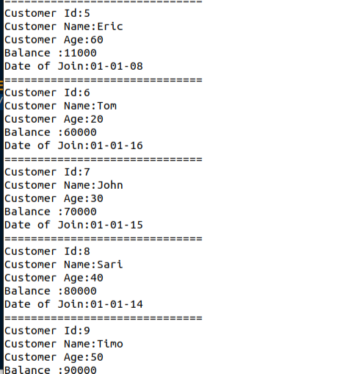

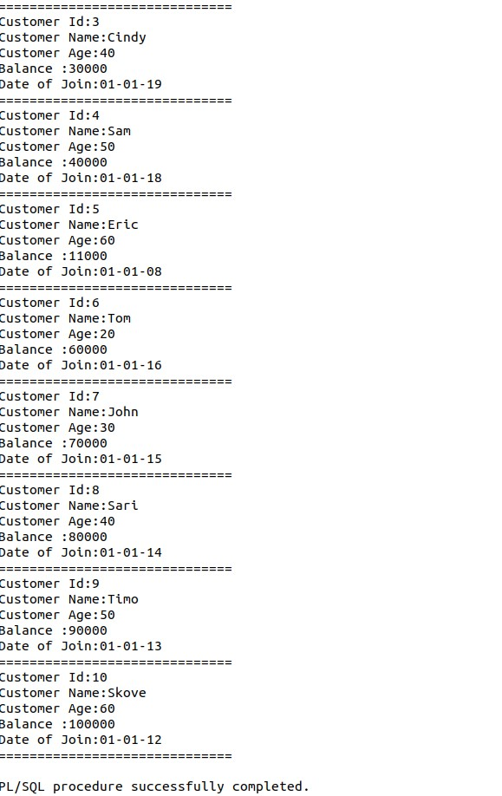

e_age Customer.id%type;

e_doj Customer.doj%type;

BEGIN

-- open cursor

OPEN cursor0;

LOOP

FETCH cursor0 INTO e_id, e_name, e_age, e_bal, e_doj;

-- exit condition

EXIT WHEN cursor0%NOTFOUND;

-- print employee info

dbms_output.put_line('Customer Id:'||e_id);

dbms_output.put_line('Customer Name:'||e_name);

dbms_output.put_line('Customer Age:'||e_age);

dbms_output.put_line('Balance :'||e_bal);

dbms_output.put_line('Date of Join:'||to_char(e_doj));

dbms_output.put_line('==============================');

END LOOP;

-- close cursor

CLOSE cursor0;

END;

**Question** 2:

**Consider the table Customer (accout no, customer name,balance amount,date of join).**

**Implement a PL/SQL block to insert those customers who have**

**current balance greater than 1 Lakh**

**and date of join before 1 january 2010 into the table premium customer**

**who doesnt meet above criteria are to be inserted into table nonpremium customer .**

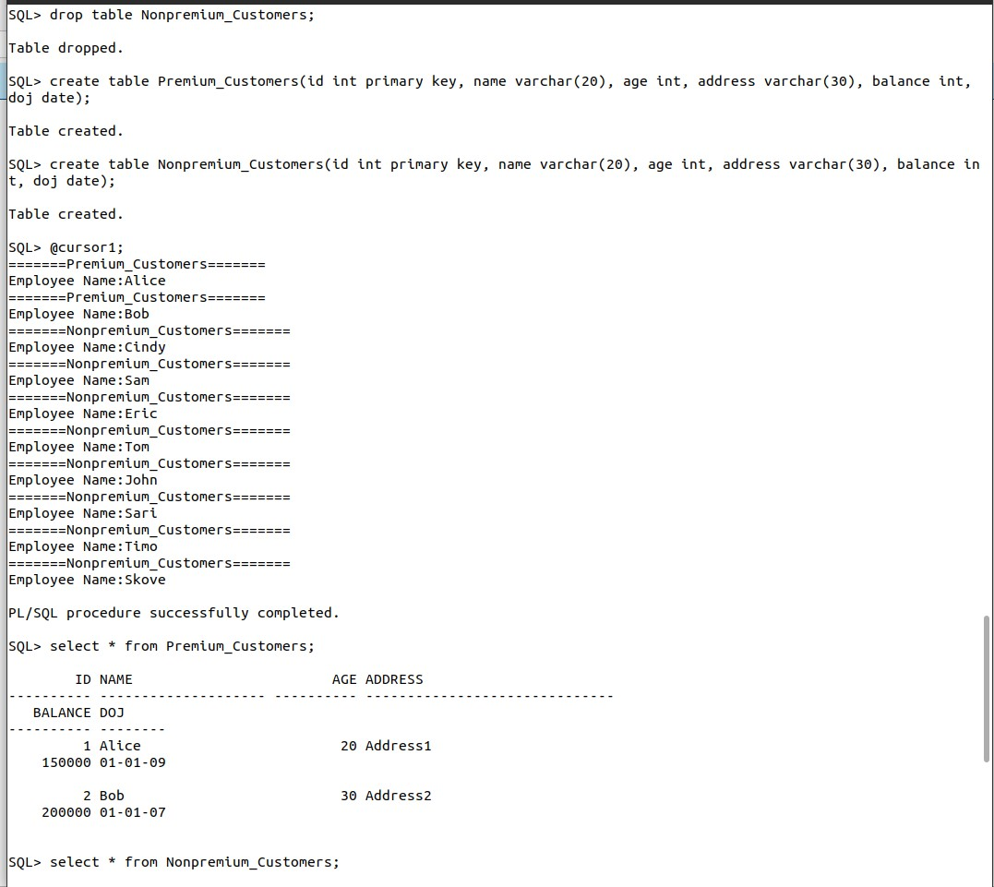

*create table Premium_Customers(id int primary key, name varchar(20), age int, address varchar(30), balance int, doj date);*

*create table Nonpremium_Customers(id int primary key, name varchar(20), age int, address varchar(30), balance int, doj date);*

*DECLARE CURSOR cursor1 IS*

*SELECT * FROM Customer;*

*BEGIN*

*-- open cursor*

*FOR c1 in cursor1*

*LOOP*

*if c1.balance > 100000 and c1.doj < '01-JAN-2010' then*

*dbms_output.put_line('=======Premium_Customers=======');*

*dbms_output.put_line('Employee Name:'||c1.name);*

*insert into Premium_Customers values(c1.id, c1.name, c1.age,*

*c1.address, c1.balance, c1.doj);*

*else*

*dbms_output.put_line('=======Nonpremium_Customers=======');*

*dbms_output.put_line('Employee Name:'||c1.name);*

*insert into Nonpremium_Customers values(c1.id, c1.name, c1.age,*

*c1.address, c1.balance, c1.doj);*

*end if;*

*END LOOP;*

*END;*

*select * from Premium_Customers;*

*select * from Nonpremium_Customers;*

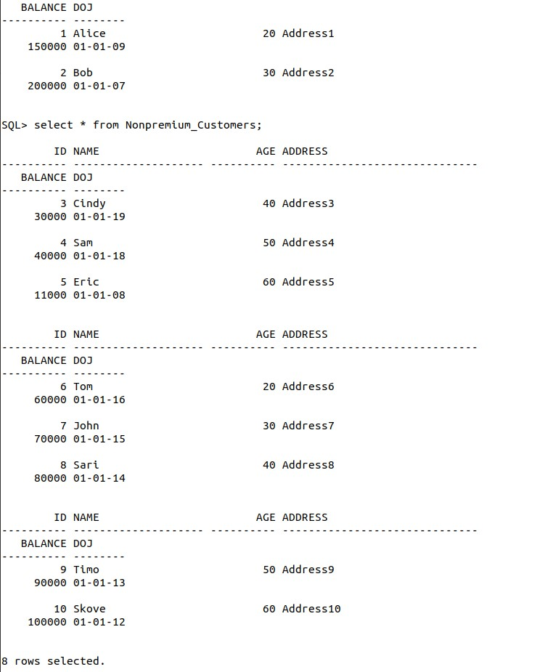

***Question 3:***

***Consider the table Account(Customer name,account number,date_last transaction,amount).***

***Implement a PL/SQL block to perform the following action on the table .***

***Calculate the interest of each person if it satisfies the condition***

***a)if the last transaction is not on the current month***

***insert the records into inactive customer***

***b)otherwise check the balance amount and display the interest amount***

***i)if the balance amount is less than 50000 interest rate is 5% of the amount***

***ii)if it is between 250000 and 5 Lakhs interest rate is 10%***

***iii)if the amount is greater than 5 lakh interest rate is 15%***

*create table AccDetails(accno number(10),cname varchar(20),lastdate date,amount number(7));*

*insert into AccDetails values(101,'Alice','08-JAN-2017',50000);*

*insert into AccDetails values(102,'Bob','10-FEB-2017',100000);*

*insert into AccDetails values(103,'Cindy','17-MAR-2017',25000);*

*insert into AccDetails values(104,'Sam','06-APR-2017',300000);*

*insert into AccDetails values(105,'Eric','15-MAY-2017',650000);*

*create table InactiveCustomer(accno number(10),cname varchar(20));*

*DECLARE CURSOR cursor2 IS*

*SELECT * FROM AccDetails;*

*iRow AccDetails %rowtype;*

*v_month number;*

*interest number;*

*BEGIN*

*-- open cursor*

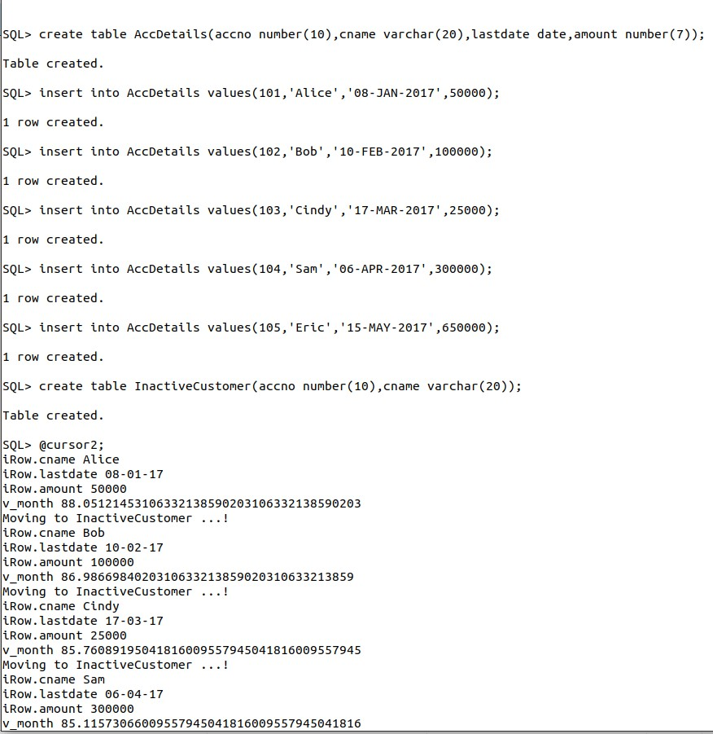

*OPEN cursor2;*

*LOOP*

*FETCH cursor2 INTO iRow.accno, iRow.cname, iRow.lastdate, iRow.amount;*

*-- exit condition*

*EXIT WHEN cursor2%NOTFOUND;*

*v_month := months_between(sysdate, iRow.lastdate);*

*dbms_output.put_line('iRow.cname '||iRow.cname);*

*dbms_output.put_line('iRow.lastdate '||iRow.lastdate);*

*dbms_output.put_line('iRow.amount '||iRow.amount);*

*dbms_output.put_line('v_month '||v_month);*

*if v_month>=1 then*

*dbms_output.put_line('Moving to InactiveCustomer ...!');*

*insert into InactiveCustomer values(iRow.accno, iRow.cname);*

*else*

*if iRow.amount < 250000 then*

*interest := iRow.amount*0.05;*

*dbms_output.put_line('interest of '||iRow.cname|| ' is :'||interest);*

*elsif iRow.amount>250000 and iRow.amount<500000 then*

*interest := iRow.amount*0.1;*

*dbms_output.put_line('interest of '||iRow.cname|| ' is :'||interest);*

*elsif iRow.amount>500000 then*

*interest := iRow.amount*0.15;*

*dbms_output.put_line('interest of '||iRow.cname|| ' is :'||interest);*

*else*

*dbms_output.put_line('Error...!');*

*end if;*

*end if;*

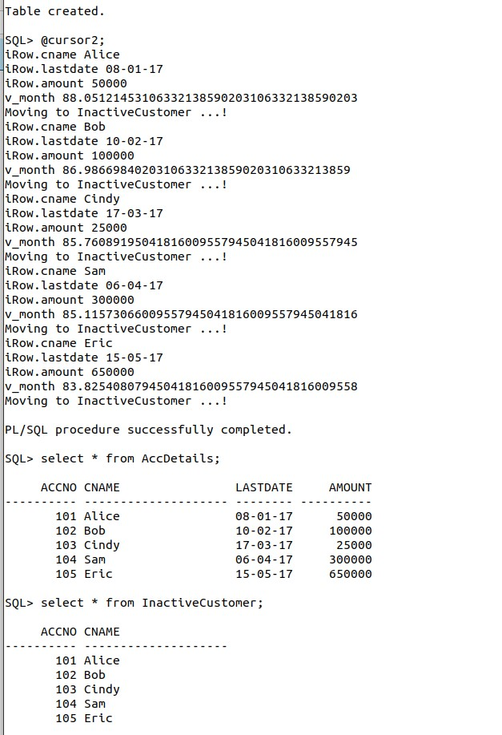

*END LOOP;*

*-- close cursor*

*CLOSE cursor2;*

*END;*

*select * from AccDetails;*

*select * from InactiveCustomer;*

***RESULT***

Studied and implemented PL/SQL Cursors